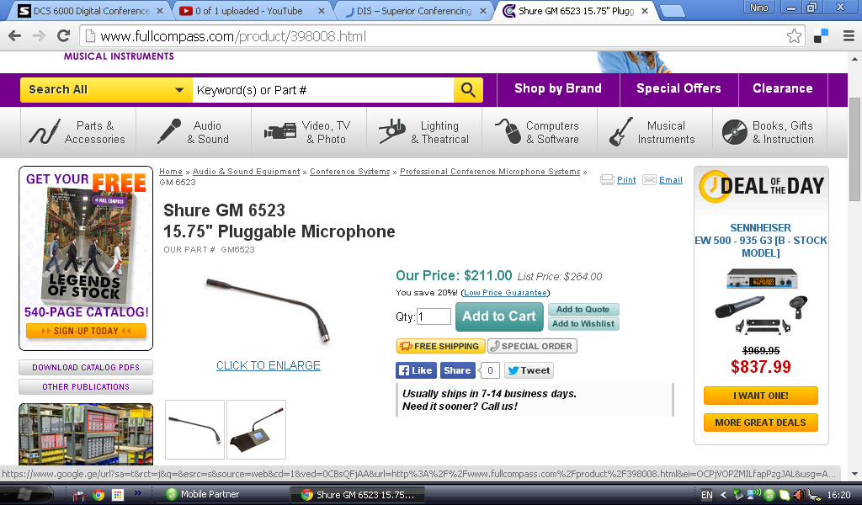

http://www.fullcompass.com/product/398008.html

