$50 Loan Instant App
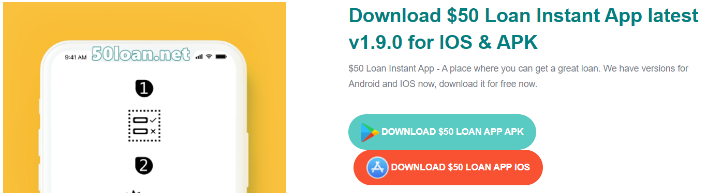
$50 Loan Instant App - A place where you can get a great loan. We have versions for Android and IOS now, download it for free now. Website : https://www.50loan.net/

https://twitter.com/50loaninstant
https://www.youtube.com/@50loaninstantapp/about
https://profile.hatena.ne.jp/loaninstantap/profile
https://50loaninstantapp.tumblr.com/
https://www.blogger.com/profile/06304402372493591859
https://www.pinterest.com/app50loaninstant/
https://www.linkedin.com/in/50loaninstantap/
https://vimeo.com/user194390286
https://issuu.com/50loaninstantap
https://www.behance.net/50loainstant
https://hubpages.com/@loaninstantap
https://dzone.com/users/4876243/50loaninstantap.html
https://www.anobii.com/en/0108cec71bb7a5eb76/profile/activity
https://www.mixcloud.com/50loaninstantap/
https://justpaste.it/u/50loaninstanta
https://hub.docker.com/u/50loaninstantap
https://folkd.com/user/50loaninstantap
https://app.lookbook.nu/50loaninstantap
https://500px.com/p/app50loaninstant?view=photos
https://www.flickr.com/people/197732152@N08/
https://about.me/instantapp
https://keeprecipes.com/user/385275/

