KINGOM OF SAUDI ARABIA …………………………………. Education directorate
MINISTRY OF EDUCATION ……………………………. Elementary school


4/2 _ 8/2 1st week From |  |  |  | Unit 1  My Friend
SB_P4 | SB_P3 | SB_P2 | Introduction & Talk Time | Unit 1  My Friend
2nd week From 11/2 _ 15/2 |  |  |  | Unit 1  My Friend
SB_P7 | SB_P6 | SB_P5 | Talk Time , Rhythms & Sounds | Unit 1  My Friend
3rd week From 18/2 _ 22/2 |  |  |  | Unit 1  My Friend
SB_10 | SB_9 | SB_P8 | Words & Phonics | Unit 1  My Friend
4th week From 25/2 _ 29/2 |  |  |  | Unit 1  My Friend
SB_P29 | SB_P28 | SB_11 | Phonics & Phonics practice | Unit 1  My Friend
From 2/3 _ 6/3 5th week |  |  |  | Unit 2  My Body
SB_P13 | SB_P12 | 4 Skills | Talk Time & Tasks | Unit 2  My Body
From 9/3 _ 13/3 6th week |  |  |  | Unit 2  My Body
SB_P15 | SB_P14 | إجازة اليوم الوطني | Rhythms & Sounds | Unit 2  My Body
From 16/3 _ 20/3 7th week |  |  |  | Unit 2  My Body
SB_30 | SB_17 | SB_P16 | Words & Phonics practice | Unit 2  My Body
From 23/3 _ 27/3 8th week |  |  |  | Unit 2  My Body
SB_P31 | SB_P19 | SB_P18 | Phonics & Phonics practice | Unit 2  My Body
From 30/3 _ 4/4 9th week |  |  |  | Unit 3  My Family
SB_P21 | SB_P20 | Grammar & vocabs | Talk Time & Tasks | Unit 3  My Family
From 7/4 _ 11/4 10th week |  |  |  | Unit 3  My Family
SB_P33 | SB_P22,23 | SB_P32 | Rhythms & Sounds, Phonics Pr | Unit 3  My Family
From 14/4 _ 18/4 11th week |  |  |  | Unit 3  My Family
إجازة مطولة | SB_P25 | SB_P24 | Words & Phonics practice | Unit 3  My Family
From 21/4 _ 25/4 12th week |  |  |  | Unit 3  My Family
Language use | SB_P26,27 | SB_P34 | Phonics & tasks | Unit 3  My Family
From 26/4 _ 30/4 |  |  |  | 13th  week
End of the continuous evaluation  Remedial Plans |  |  |  | 13th  week
SYLLABUS DISTRIBUTION FOR 1st ELEMENTARY GRADE (WE CAN 1) (FIRST TERM) 1445 H

إجازة مطولة إجازة اليوم الوطني

Teacher…………….… Headmaster………………. Supervisor ……………….

SB كتاب الطالب WB كتاب النشاط Pرقم الصفحة بكتاب الطالب

توضيح مهم ل
Tasks المدرجة بالتوزيع
- هي مهام ادائية وانشطة داخل الحصة كأوراق العمل وحل كتب النشاط على المهام المطلوبة سواء كانت 4 skills اللي هي المهارات الأربع ( قراء و كتابة و تحدث واستماع )

- او مهارات المفردات والقواعد grammar and vocabs
او مهارات استخدام اللغة وتكوين الجمل language use وهكذا

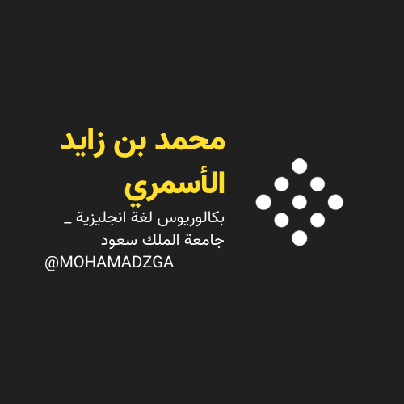



MOHAMADZGA M_zaid0

لا تنسوني من صالح دعائكم

