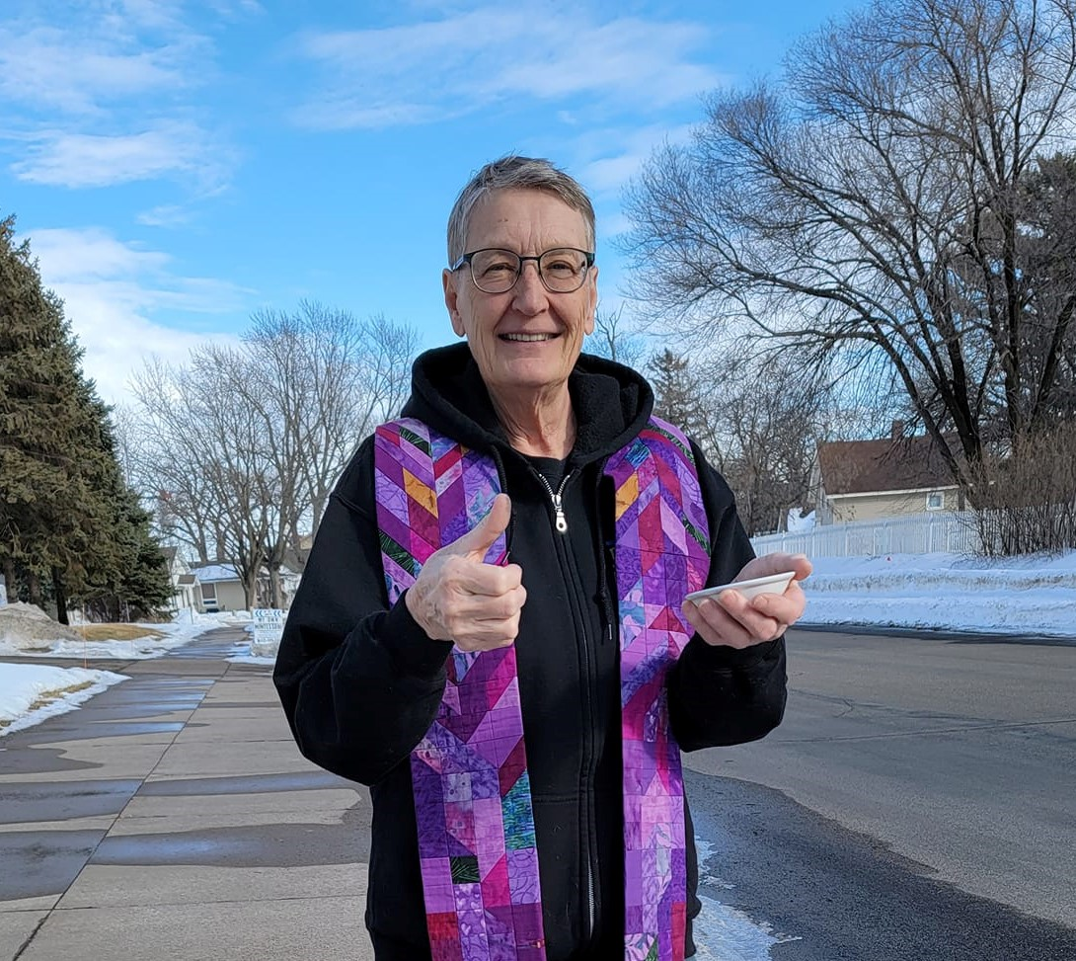

June 26, 2022, 10 a.m.
A Celebration of the Ministry
of Reverend Robin Raudabaugh
with
Union Congregational Church
United Church of Christ
Elk River, Minnesota 55330
763-441-1203
www.elkriverucc.org
churchoffice@elkriverucc.org

Welcome!

Union Congregational Church, United Church of Christ welcomes everyone, no matter who you are or where you are on your faith journey.

We oﬀer worship via Facebook Live broadcasts every Sunday at 10am. You can be here in person or participate virtually during, or any time after the service. Every Sunday, the service is recorded and broadcast on Facebook. You can contact the church at any time. See oﬃce hours below.

Please SILENCE cell phones during the service.
The wi-fi password is: stillspeaking1203


VISION
God has shown you, O mortal, what is good. And what does the Lord require of you? To act justly and to love mercy and to walk humbly with your God.
(Micah 6:8, (NIV))

Union Congregational Church, United Church of Christ Mission Statement

God calls us to minister to each other. This ministry goes beyond our congregation into the community, wider world, and to the earth itself. We seek to reach those in the margins of society, to empower the powerless, and to leave this earth a better place than when we each arrived

LIGHTING THE CANDLES

PRELUDE

WORDS OF CENTERING

Times of transition are strenuous, but I love them. They are an opportunity to purge, rethink priorities, and be intentional about new habits. We can make our new normal any way we want.
~Kristin Armstrong

WELCOME

If you are in-person, we invite you to fill out the friendship pad to let us know you are here.

If you are worshipping virtually, we invite you to click a reaction button on Facebook to let us know you are with us.



is located in the Vestry. (the room off of the sanctuary)
Also, in the back of the sanctuary, is a table with items and bags for activities appropriate for the kids to work on and play with during the service. Children are welcome to sit at the table or bring the bag back to sit with parents.

CHORAL CALL TO WORSHIP 283 “Spirit of the Living God”
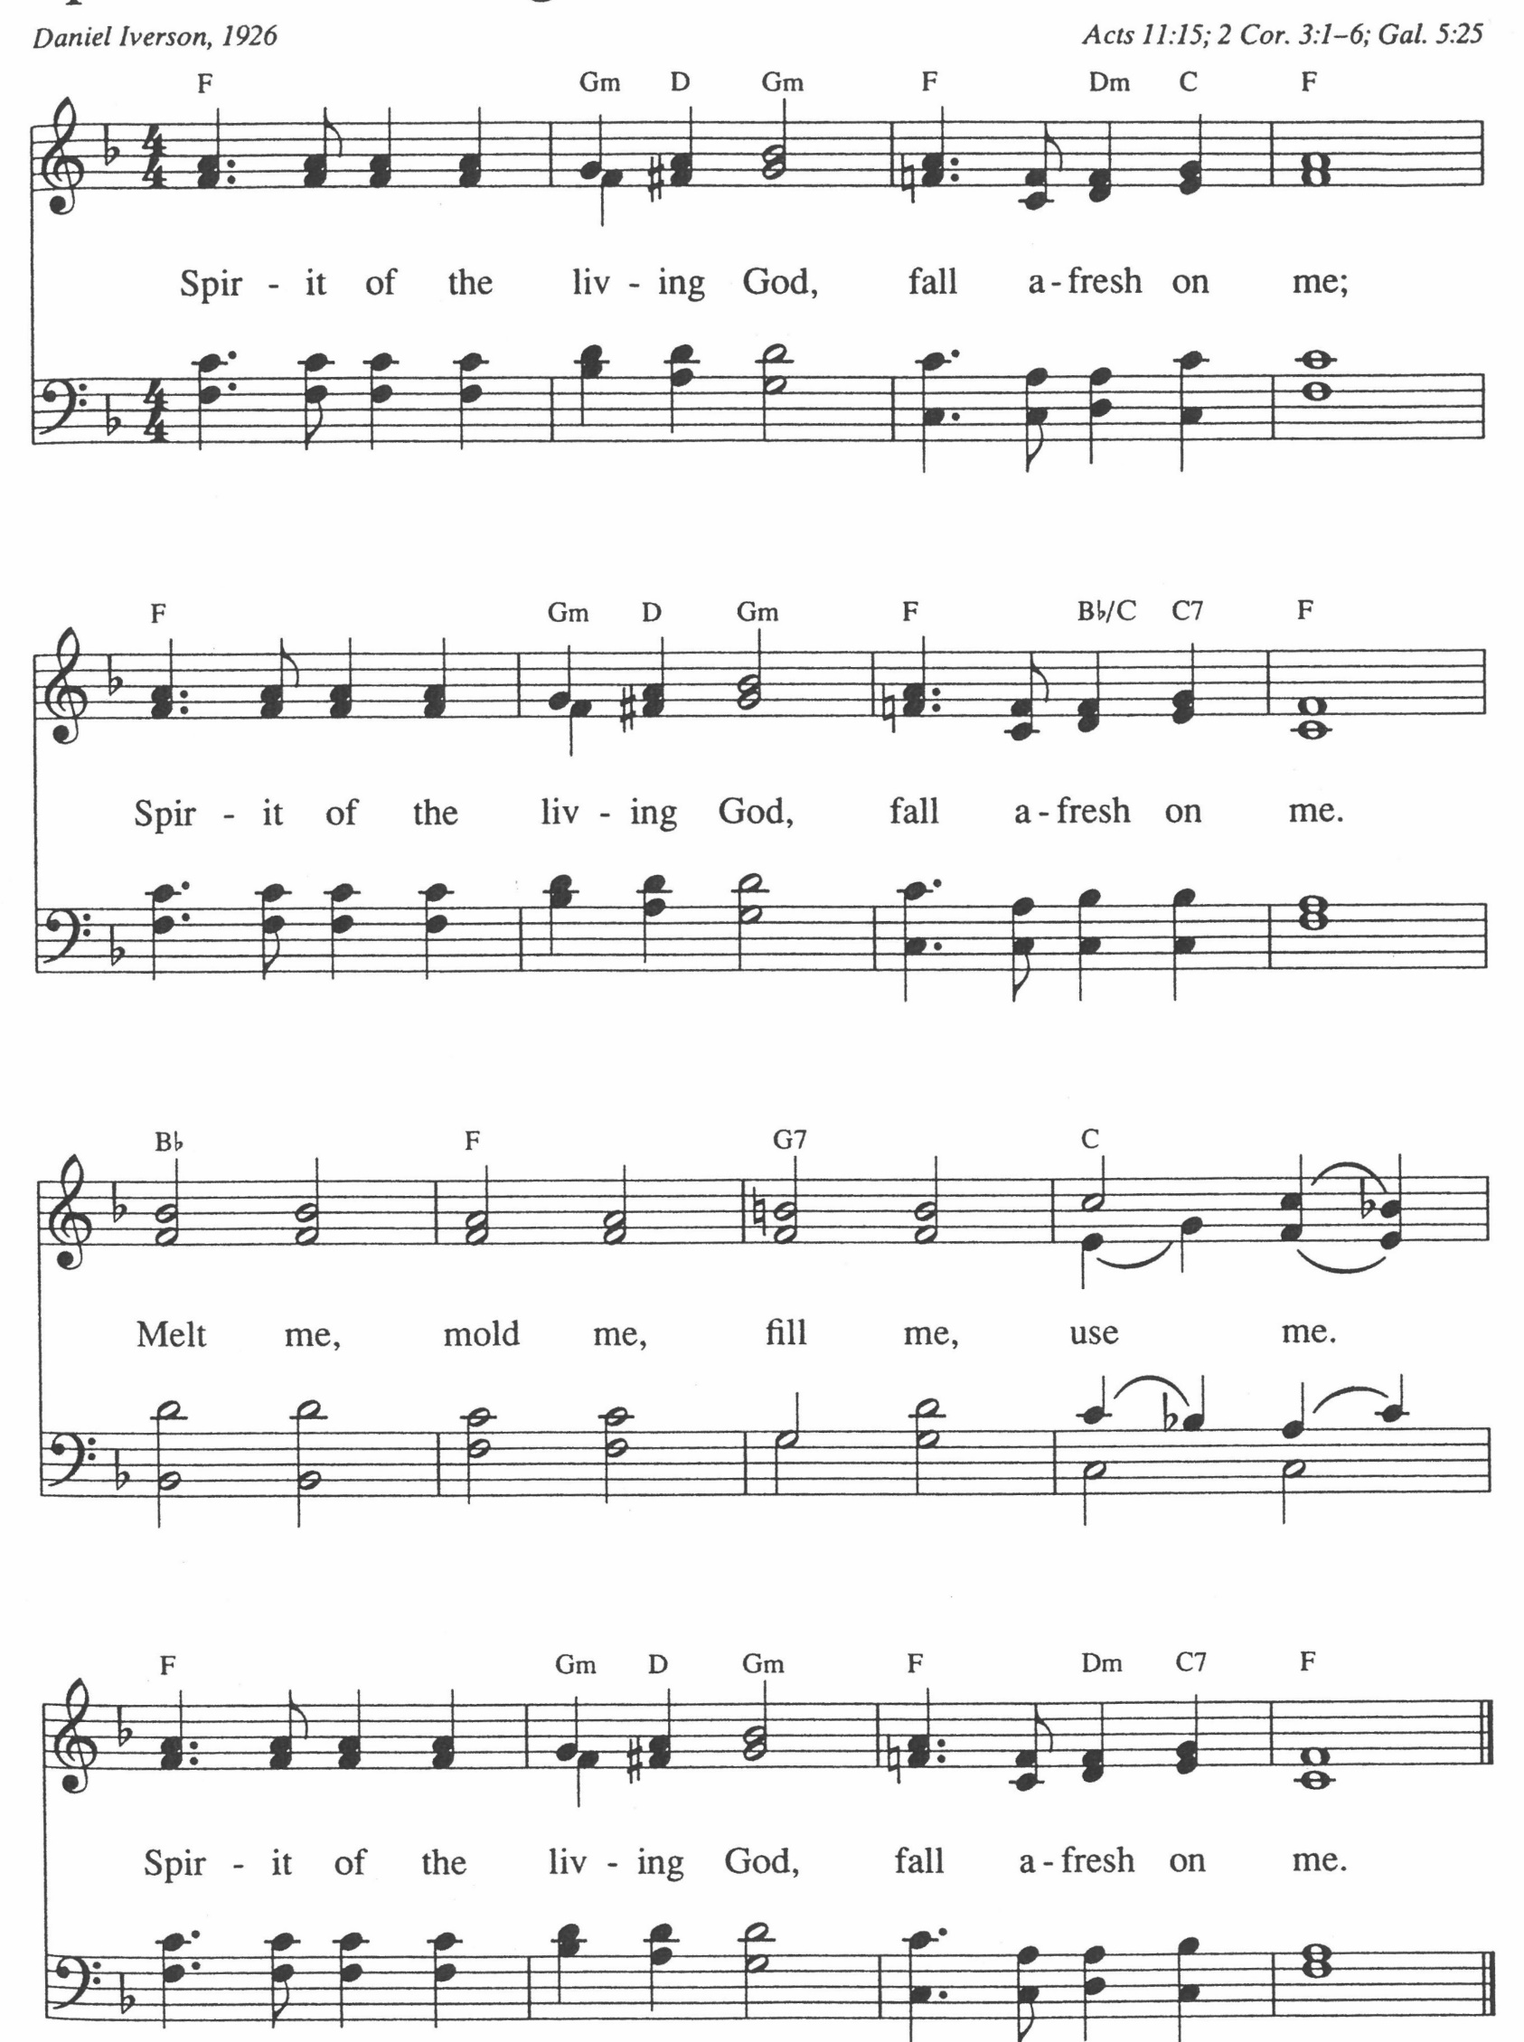
Marce Ediger:

CALL TO WORSHIP (PLEASE JOIN IN CALL AND RESPONSE)

One: Holy One of All That Is, we give you thanks that you are
among us.

Many: We thank you for the gift of your creation; for the gift of friends and family;

One: For the gift of stories; for the gifts of learning and knowledge;

Many: For the gifts of question and doubt; for the fire of passion and enthusiasm; for the wind of reason.

One: For all we understand, for all that remains a mystery, for your loving presence in and through it all, we give you thanks.

HYMN 32 “God of the Sparrow, God of the Whale”
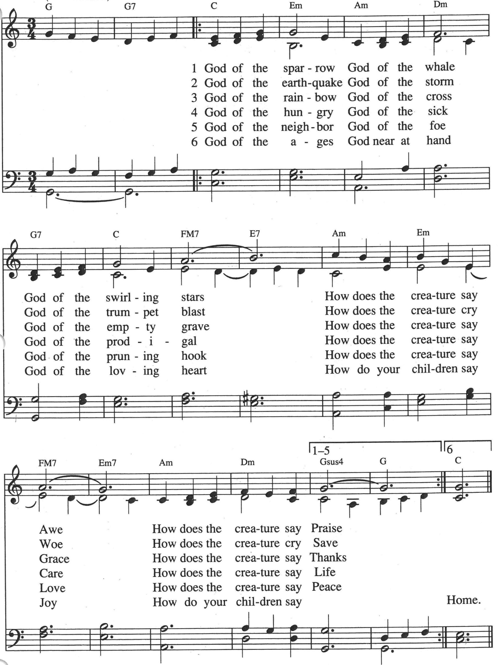

John Olson:

LIGHTING THE PEACE CANDLE & PEACE PRAYER

GREETING OF PEACE

In the same spirit in which we receive the unconditional love of God in Jesus Christ, let us oﬀer to one another our own sign of peace.
One: The Peace of Christ be with you.

Many: And also, with you.

SPECIAL MUSIC Hesther Bowman, Gigi Nauer, Marilyn Olson
CHILDREN’S TIME Pastor Robin

Paula Foley:
SCRIPTURE Matthew 13: 3-9 NRSV

And he told them many things in parables, saying: ‘Listen! A sower went out to sow. And as she sowed, some seeds fell on the path, and the birds came and ate them up. Other seeds fell on rocky ground, where they did not have much soil, and they sprang up quickly, since they had no depth of soil. But when the sun rose, they were scorched; and since they had no root, they withered away. Other seeds fell among thorns, and the thorns grew up and choked them. Other seeds fell on good soil and brought forth grain, some a hundredfold, some sixty, some thirty. Let anyone with ears listen!’

REFLECTION Planting Seeds
HYMN 528 “Sois a Semilla” (You Are the Seed) vs. 1 & 3
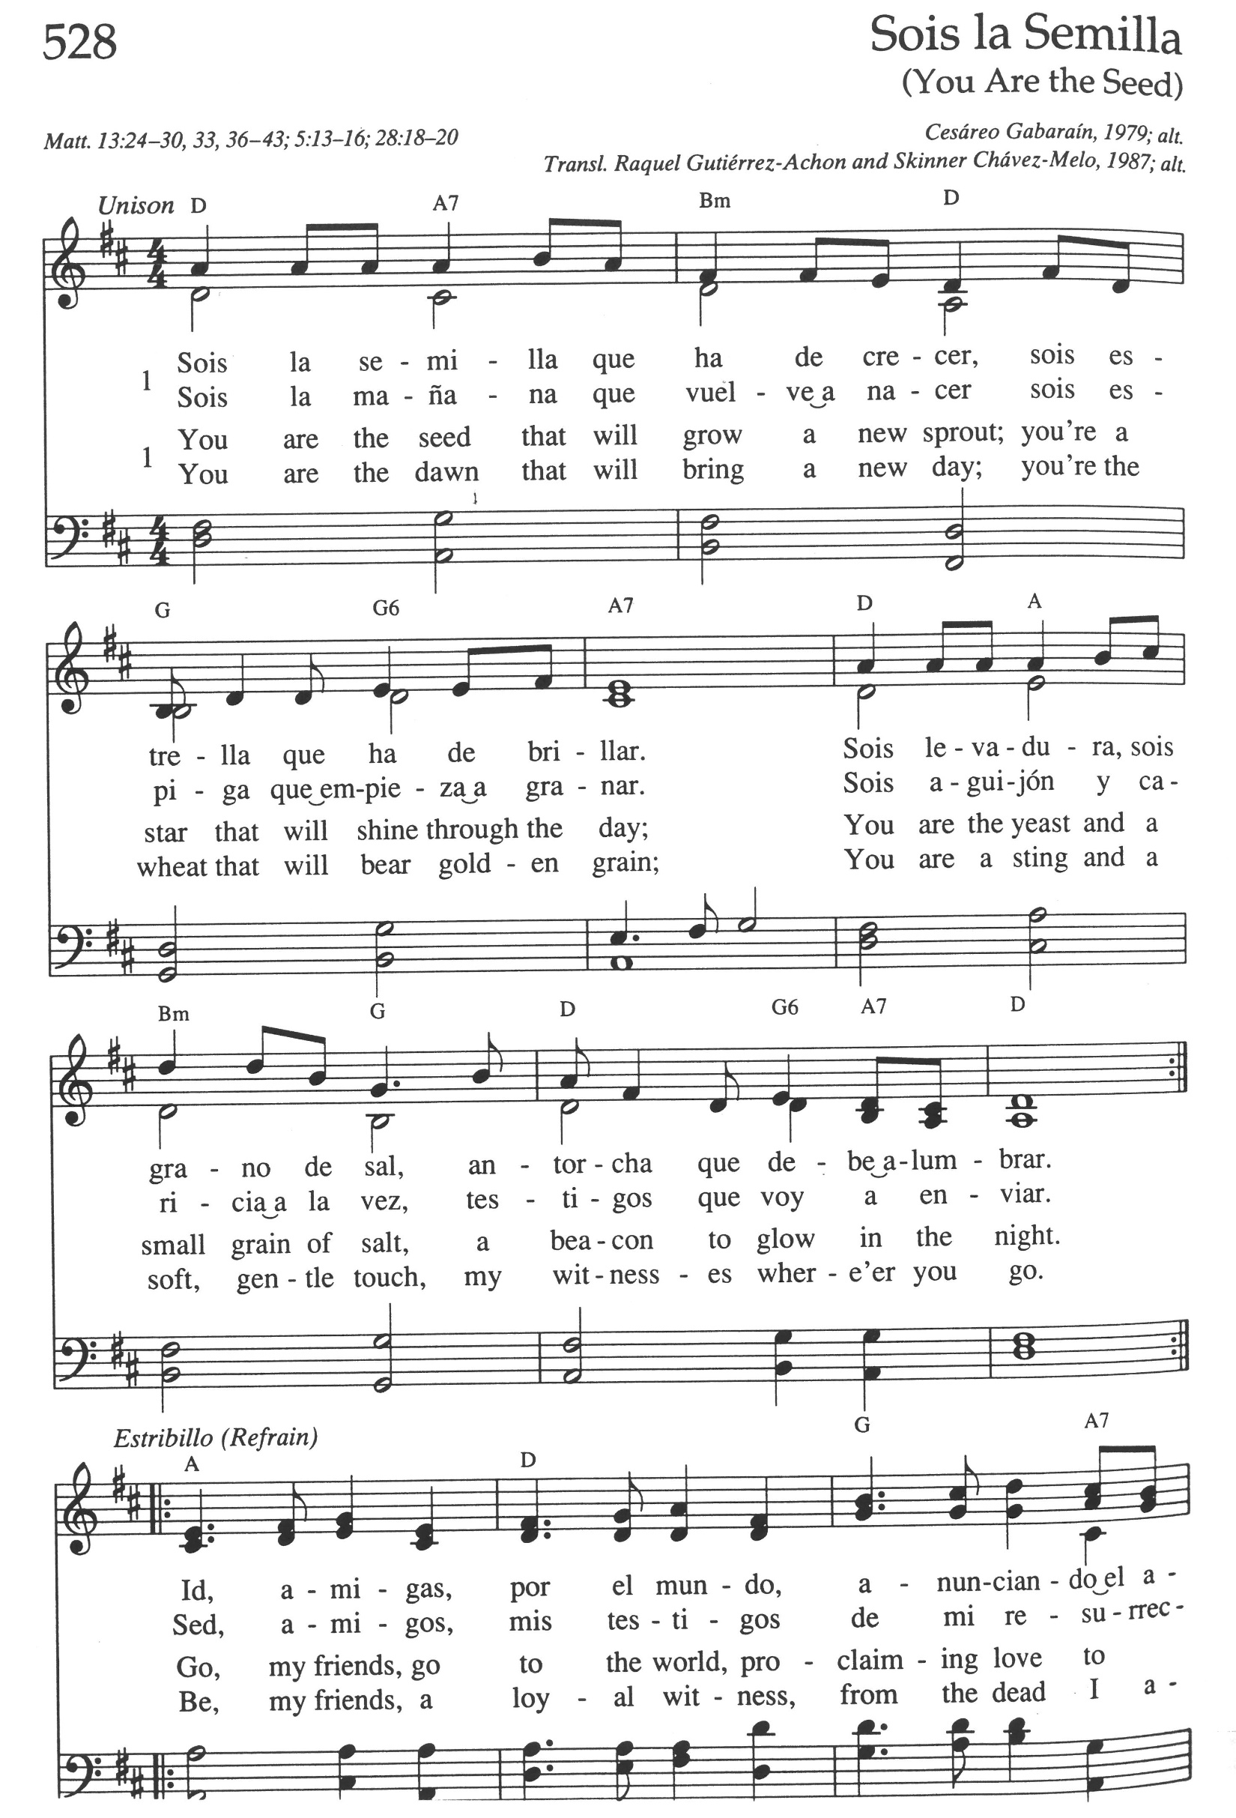
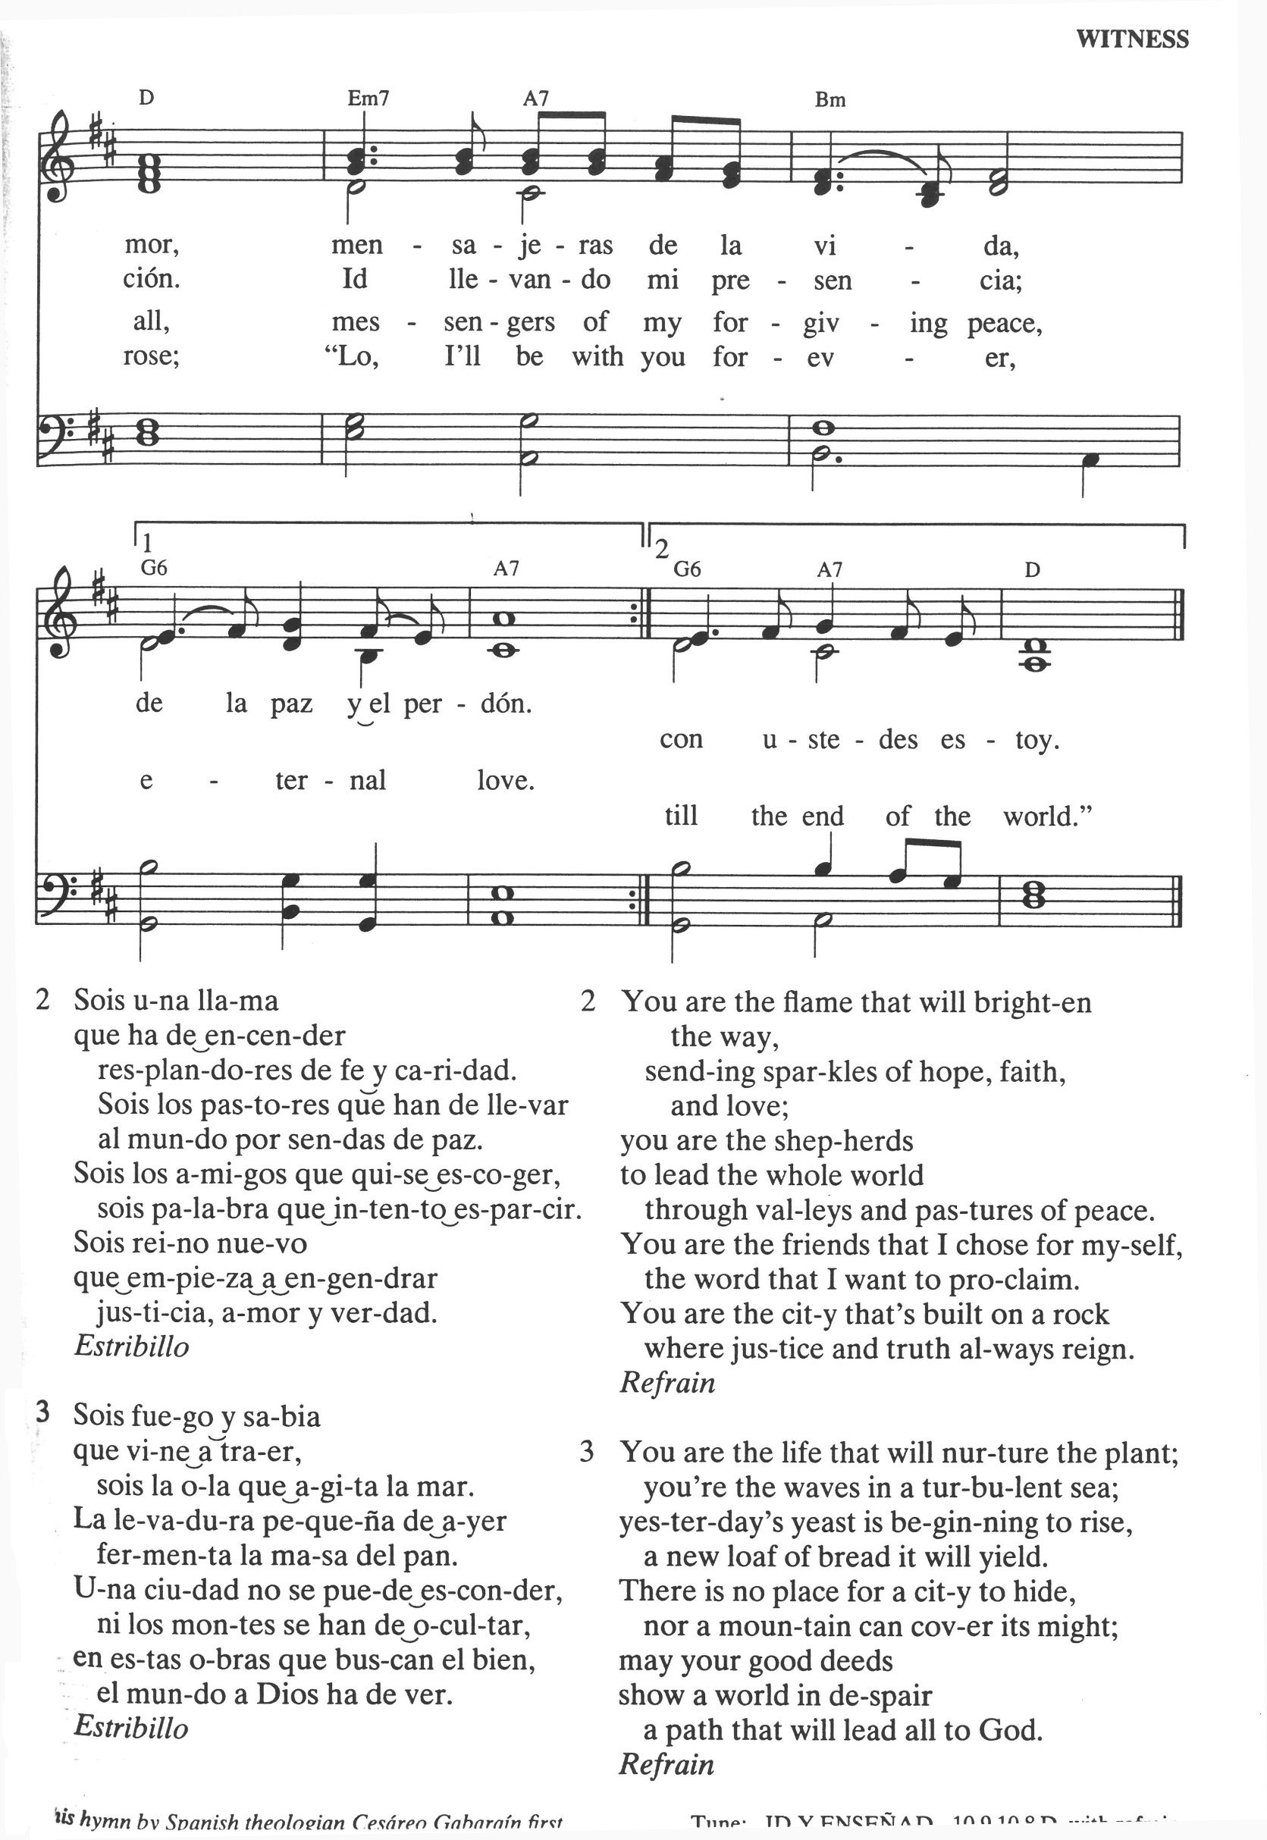
LITURGY OF FAREWELL

Dave Foley:
Our church family is constantly changing.
People come and go.
Babies are born.
Children grow up.
People commit themselves to one another.
Loved ones and friends among us come to the end of their lives.
Individuals move into our community and church life.
Others leave us, moving away to new places, new experiences, and new opportunities.
It is important and right that we recognize these times of passage, of endings and beginnings.
Today, we share the time of farewell with Pastor Robin who is leaving.

REMEMBERANCE AND RECOGNITION / GIVING AND SHARING SYMBOLS

ENDING AN AUTHORIZED MINISTRY

Marietta Saxon:
On February 11, 2016, this local church called Rev. Robin Raudabaugh to serve as Revitalizing Pastor, and on November 18, 2018, she was called as Pastor.

Pastor Robin:

I thank Union Congregational Church, United Church of Christ, its members, and friends, for the love, kindness, and support shown me these last 6 years. I ask forgiveness for the mistakes I have made.
I am grateful for the ways my leadership has been accepted. As I
leave, I carry with me all that I have learned here.

PEOPLE: We receive your thankfulness, offer forgiveness, and accept that you now leave to minister elsewhere.
We express our gratitude for your time among us.
We ask your forgiveness for our mistakes.
Your influence on our faith and faithfulness will not l leave us at your departure.

Pastor Robin: I forgive you and accept your gratitude, trusting that our time
together and our parting are pleasing to God.

VOWS OF RELEASE

Patti Kubicka: Do you, the members and friends of Union Congregational Church, United Church of Christ release Rev. Robin Raudabaugh from the duties of Pastor.

People: We do, with the help of God.

Patti: Do you offer your encouragement for her ministry as it unfolds in new ways?

People: We do, with the help of God.

Patti: Do you, Pastor Robin, release this local church from turning to you and depending on you?

Pastor Robin: I do, with the help of God.

Patti: Do you offer your encouragement for the continued ministry here and on the relationship with another who will come to serve?

Pastor Robin: I do, with the help of God.

WITNESS OF THE CONFERENCE

Rev. Cindy Mueller:
On behalf of the MN Conference of the United Church of Christ, I witness to the words spoken: words of thankfulness, forgiveness, and release.
The member churches of our Association and Conference hold each of you in prayer. We pledge our support in the transitions signified in this service.

Union UCC Leaders: Thanks be to God

Marylyn Bowman: Let us pray.

People: God, whose everlasting love for all is trustworthy, help each of us to trust the future which rests in your care. The time we were together in your name saw our laughter and tears, our hopes and disappointments. Guide us as we hold these cherished memories but move in new directions, until that time to come when we are completely one with you and with each other, in the name of Jesus Christ we pray. Amen.

Marylyn: Go, surrounded by our love, and led by the promises of God, the
presence of Jesus Christ, and the guidance of the Holy Spirit. Amen.

OUR TIME OF SHARING JOYS & CONCERNS, ANNOUNCEMENTS & PRAYERS OF THE COMMUNITY

RECOGNITION OF GRADUATES

THE PRAYER THAT JESUS TAUGHT (let us pray together) Our Creator in Heaven, hallowed be your name.
Your kingdom come. Your will be done, on earth
as it is in Heaven.
Give us this day our daily bread. And forgive us our sins,
as we forgive those who sin against us.
Lead us not into temptation but deliver us from evil. For yours is the kingdom, and the power, and the glory forever. Amen.

INVITATION TO GIVE/RECEIVING OUR GIFTS

OFFERTORY

DOXOLOGY 108 SPP Send Your Spirit to Set Us Free
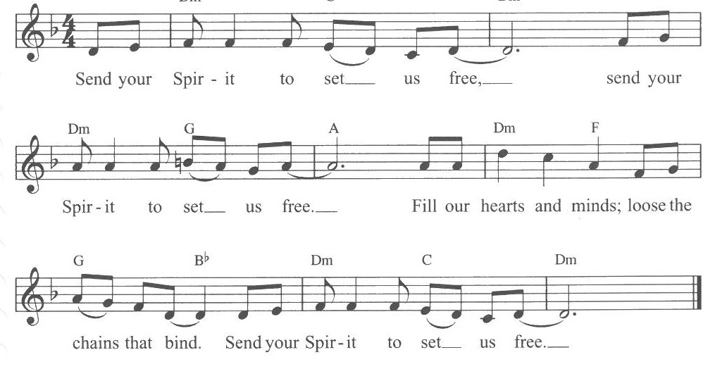

PRAYER OF DEDICATION (let us pray together)

God bless the many gifts offered that in this place and all the other places we may find ourselves, that shelter may be offered, that good food may be shared, that diversity may be celebrated, that listening and hearing one another’s stories may be enjoyed, that hard times may be weathered, and always that rainbows might light our lives. Amen.

Hymn 423 “Great is Your Faithfulness” vs. 1 & 2
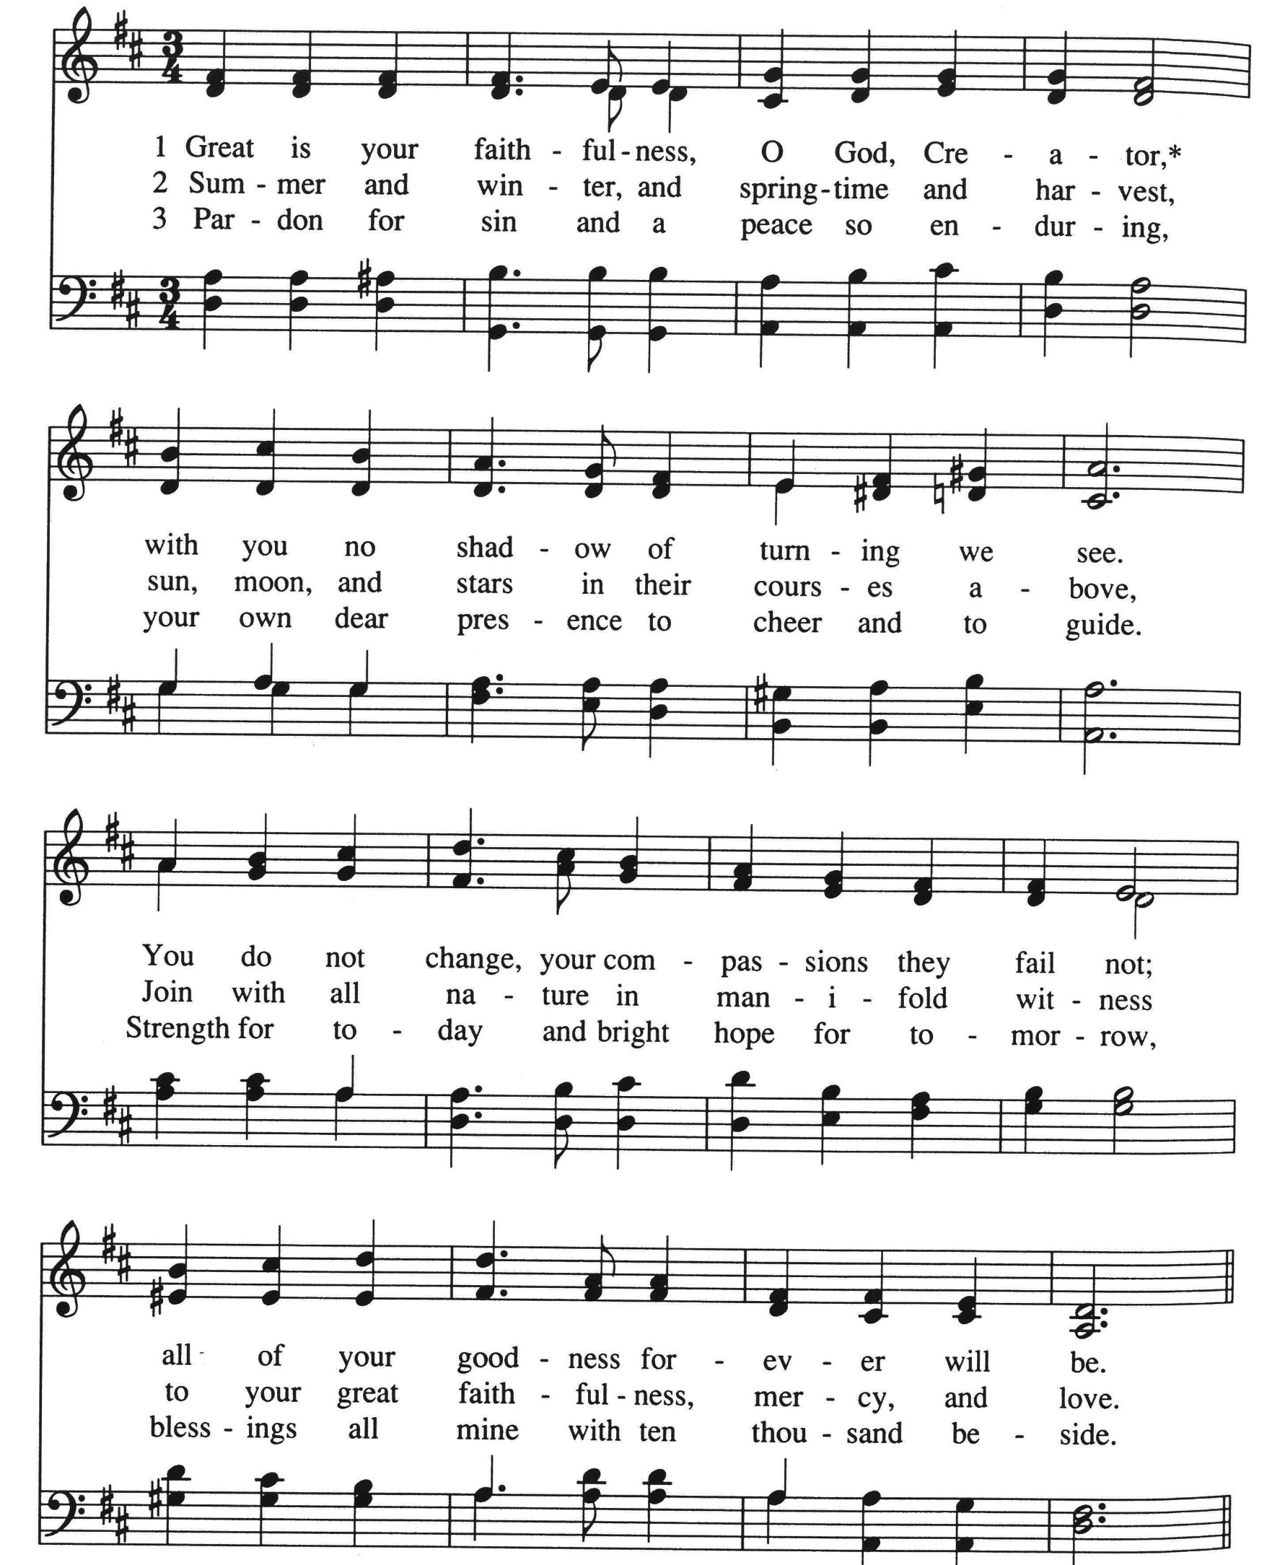

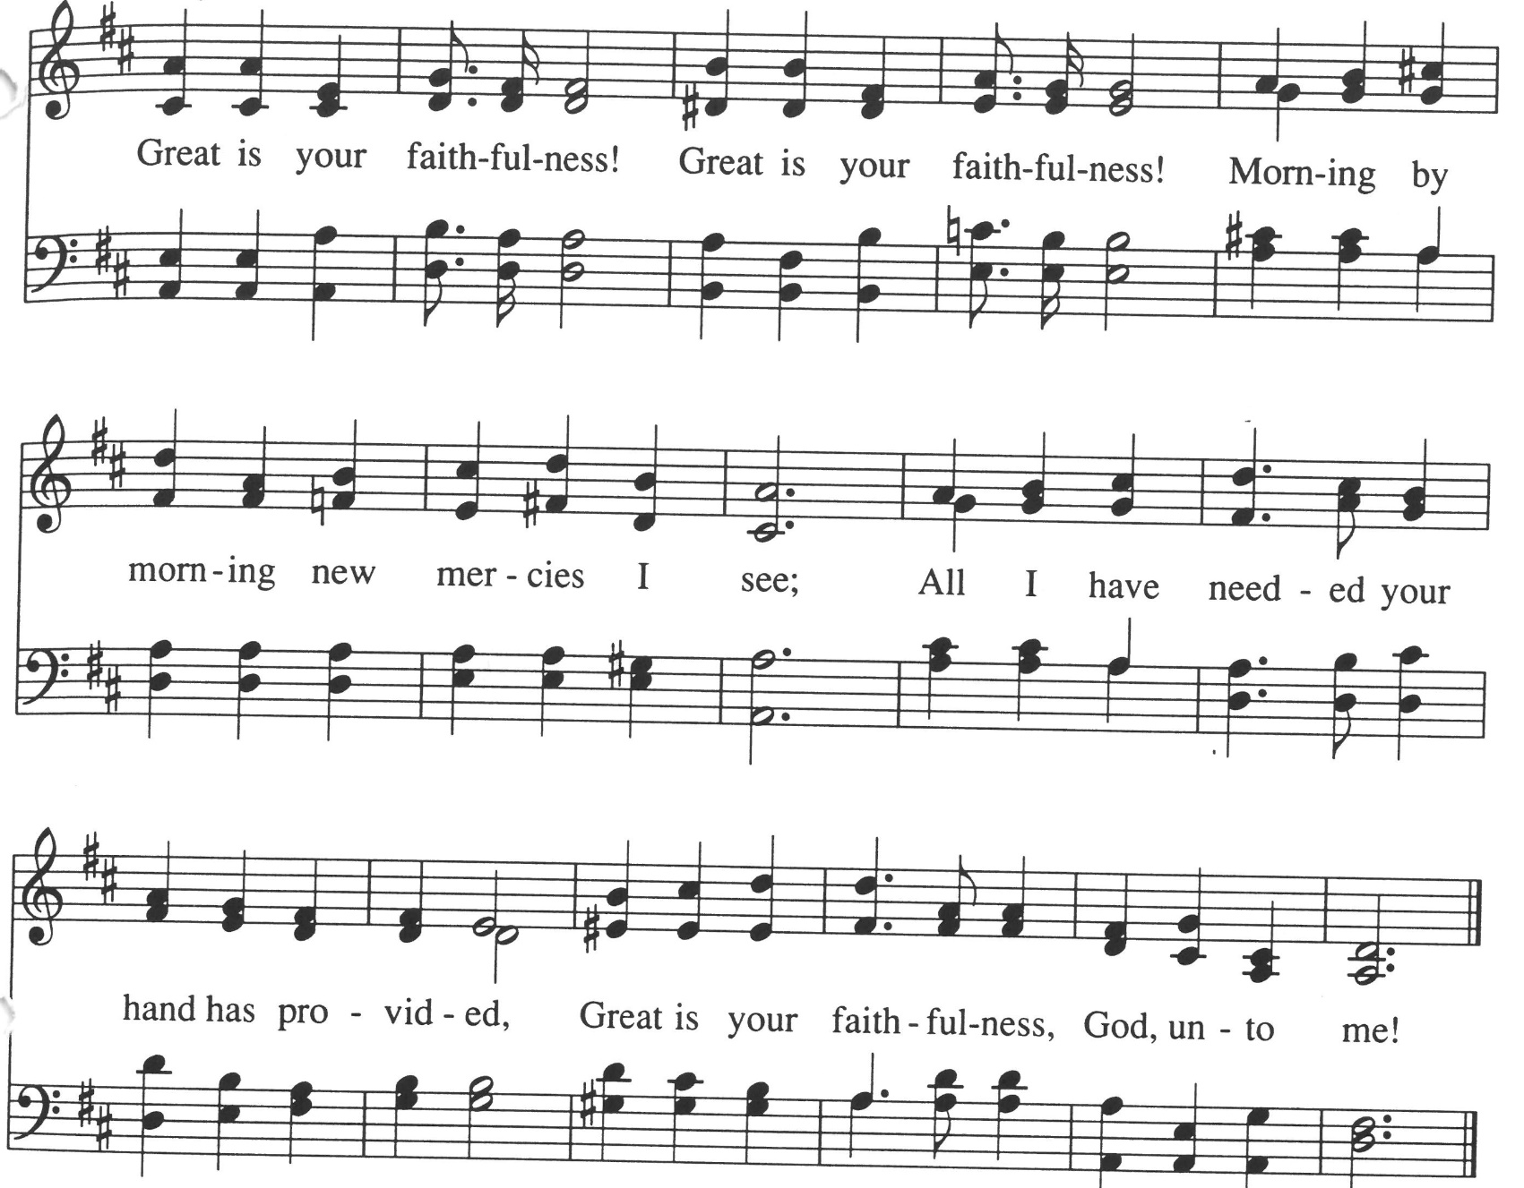

BENEDICTION

One: Like a rock,

Many: God is under our feet.

One: Like the sky above,

Many: God is over our heads.

One: Like the horizon,

Many: God is as far as we can see and beyond.

One: Like water in a pitcher,

Many: God is within us and in the pouring out of us.

One: Like a pebble in the sea,

Many: We are in God.

One: Let us go out and change the world,

Many: As God has changed our lives. Amen.

POSTLUDE

All re-printed music is licensed under CCLI 11010370

Elk River Union Congregational Church, United Church of Christ Pastor: Rev. Robin Raudabaugh Deacon: Joyce Hodge
Oﬃce Administrator: Giuliana Beckwith Greeter: Nancy & Bob Hassett
Senior Choir and Handbell Director: Children’s Time: Pastor Robin
Piano & Organ: Carson Schneider

Announcements

Oﬃce Hours
Oﬃce hours for the church are Sunday 9:00am to 1:00pm before and after worship, Monday/Wednesday 8:00am-1:00pm. Call the church at (763) 441-1203 during office hours if you have general questions. If you leave a message after hours, your call may not be returned until the office is open. If you need a pastor immediately, please contact Pastor Robin via the information below. The oﬃce email is churchoﬃce@elkriverucc.org.

Pastor Robin is generally in the office M, T, W mornings. If you would like to meet with her in person, it is a good idea to call ahead.

Pastoral Emergencies
In the event of an emergency, an accident, or a death, even while Pastor Robin is on vacation, please contact her directly via text at 651.216.9012, phone or email revrobin@elkriverucc.org. You may also contact the church office though the response may take longer.

Church Materials
Copies of the Sunday sermon and bulletin are available in person or via Facebook, our website, and the UCC Squared Newsletter (email).

KEPT IN OUR PRAYERS
Please keep in your prayers our congregation members: Nancy Hassett, Ella Rivers, Musz Bailey, Jim Babcock, Shelley Sherper, Bobbie Berg, Susan Olsen, Joanne Burdick, Ruby Cawthra, Jane Houlton, Marion Marcott, Cheryl Wold, Judy Halgren, Bailey Rosdahl, Jimmy Stevens, Dee & Jim Stevens (Jimmy’s parents), Linda Fenton, Dave Halgren, Joan Axen, Marv and Nancy Andersen, Laurie Lazaretti, and Jim Kopperud.

SCHEDULE FOR THE COMING WEEKS

Sunday, June 26, 2022
10:00 a.m. Worship Service In-person and live via Facebook
Celebration of Rev. Robin’s Ministry
and Farewell Sunday
7:00 p.m. Youth Group

Tuesday, June 28, 2022
5:00 p.m. Congregational Life

Wednesday, June 29, 2022
3:30 p.m. SARI Vigil Sherburne
County Gov’t center

Thursday, June 30, 2022
6:00 p.m. Girl Scouts
6:30 pm Pastoral Relations

Friday, July 1, 2022
6:00 p.m. Girl Scouts

Sunday, July 3, 2022
10:00 a.m. Worship Service In-person and live via Facebook
-Welcome Rev. Jeanne Bringgold-Pro
-Communion Sunday

Wednesday, July 6, 2022
3:30 p.m. SARI Vigil Sherburne
County Gov’t center

Thursday, July 7, 2022
9:00 a.m. 4-H Club
6:00 p.m. Girl Scouts
6:30 pm Council Meeting

Thursday, July 8, 2022
6:00 p.m. Girl Scouts

