Recent Information about Ilgamos & Ilcoin.
Aleksandar Bozovic, Executive Director

Dear Ilgamos Partner,
BREAKING NEWS: ILCoin LISTED ON C-CEX!!
We are excited to announce that our own digital currency, ILCoin is now listed on C-Cex, probably the world's most widely recognized digital currency exchange (please click on https://c-cex.com/?p=ilc-btc for details).

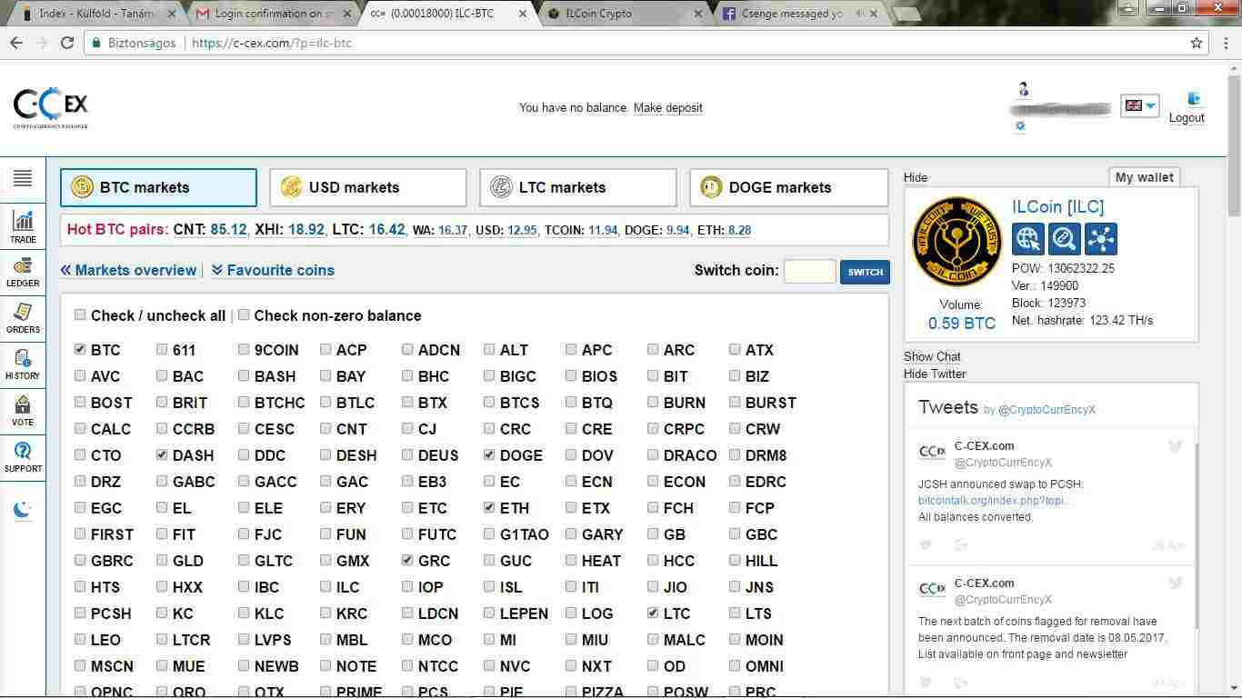
Ilgamos has promised - and Ilgamos has delivered. Again.
Now there can be no doubt in anyone's head about the quality and legitimacy of ILCoin. A few weeks ago ILCoin was voted as the No. 1 digital currency among all coins listed on ther C-Cex platform. Now, after carefully analysing our tech base - blockchain, wallets and block explorer - C-Cex approved ILCoin for live trading on its trading platform.

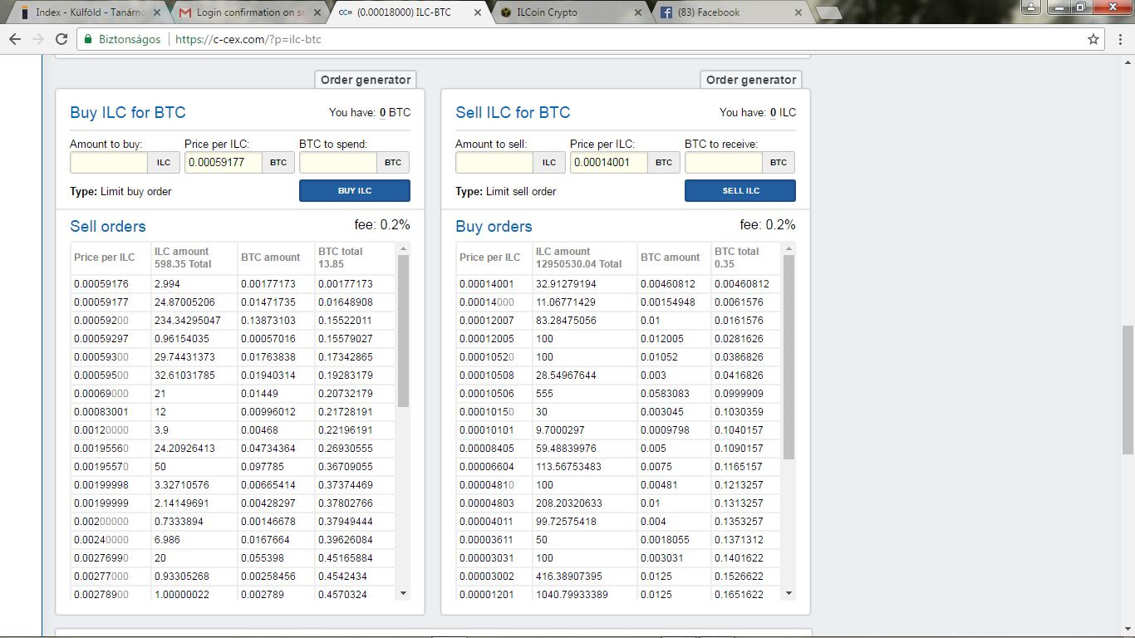 You can also find the official ILCoin web page link: http://ilcoincrypto.com/ on the C-Cex.com page.
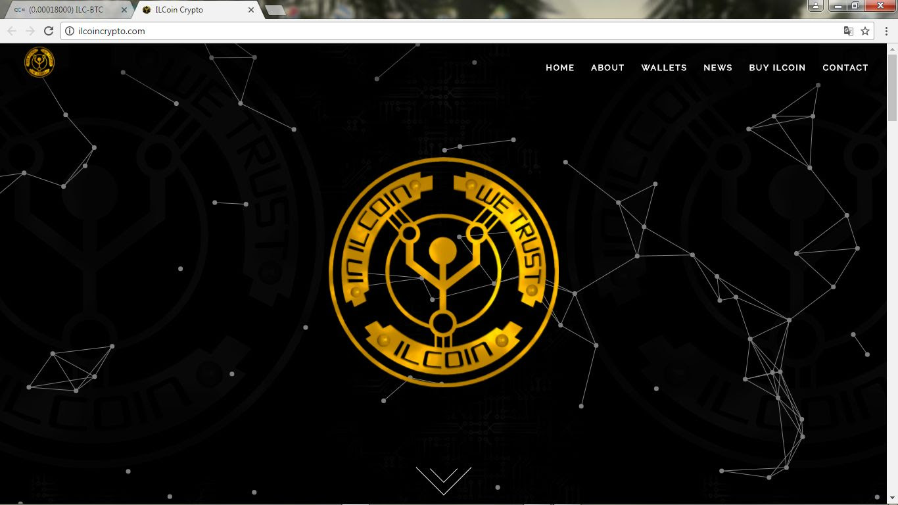

And if this is not enough: just hours after ILC started trading on C-Cex, several other exchanges connected with C-Cex also started listing our digital currency! Check these links: https://bitinfocharts.com/ilcoin-exchange-charts.html and https://cryptrader.com/charts/ccex/ilc/btc and https://www.cryptonator.com/exchange/ccex/.

This is nothing short of a sensation in the history of Ilgamos and ILCoin. C-Cex is the first digital currency exchange where ILCoin can now be traded, and there will be more to follow as we move forward.

Naturally, we still have a long way to go. We need to work together - company and you, our partners - to build the user base of the global ILCoin based economy. You invite more and more new partners to join our community: tell the world you work with a digital currency that can already be used to buy a wide range of products and services on the first digital currency based global e-marketplace!

In the meantime, Ilgamos continues to develop the technological base: in a few days, our new, enhanced internal ILC trading platform will be launched, plus we are developing new merchant platforms where ILCoins can be used.

This will provide an ever stronger support for ILCoin which will be reflected in the rise of its open market price as we look into the future.

Now that Ilgamos and ILCoin have taken on a new dimension, certain business rules will have to be adjusted in the near future, reflecting today's vastly different trading conditions. We will keep you informed through nour regular newsletters.

Developing a new, digital currency based global economic system is a difficult, but rewarding job. Working together we are building an empire. The listing of ILCoin on C-Cex is yet another milestone on the road.

Ilgamos stands out among all crypto companies with its ILCoin: a real, recognized digital currency destined to be amazingly successful.

Business presentation Ilgamos
http://www.mybestdeal4you.ilgamos.com http://www.ilgamos-4you.blogspot.com
Wannasave is a international company that has developed a revolutionizing concept for the retail market.
Wannasave offer the merchants a clever and easy way to build their own online communities.
Our tools secure a close communication with their consumers.
The concept is build as a WIN-WIN-WIN model for the consumer, the merchants and wannasave. Also, the wannasave concept will generate a loyal group of both online and offline consumers, sorted by several demographic pieces of personal information and thereby enable the merchants to maximise the effect of their marketing budget. Wannasave are now creating international partnerships with people and organisations who can support, and benefit, from our global expansion! www.wannasave.com/mybestdeal4you

