Apple cake
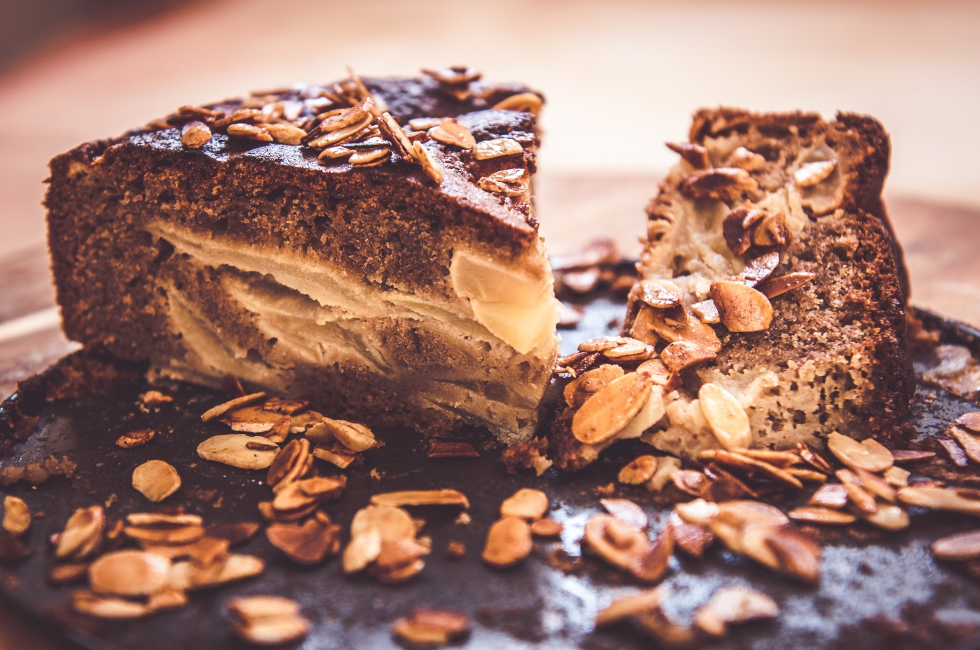
Ingredients: Preparation time: 1h 45min
- 4 organic or free rage eggs
- 110g brown sugar
- 200g self-raising flour
- 150g melted butter
- ½ tsp cinnamon
- 1 tsp ginger powder
- Pinch salt
- Pinch turmeric
- 50g Golden raisins
- Almond flakes
- Apples, peeled and seeded

Preparation:
Whisk 4 eggs with sugar; keep whisking and slowly add: melted butter, and cinnamon.
Then stir it gently with a wooden spoon and add: ginger, salt, flour, and turmeric.
Preheat the oven to 180 °C. Grease a round baking tin and sprinkle it with breadcrumbs. Stir the mixture thoroughly until properly combined. Pour the mixture into the tin and dip into it around 7–8 big chunks of apples and golden raisins and almond flakes on the top. Bake it for approx. 1.5 hours.

