Raw material | Sourced or original? | Sourced from? | Notes
Logo | Sourced | Media Department | On posters added stroke so more visible
Creative arts quote image | Sourced | http://www.pinterest.com
MEDIA TRAILER:  Into The Wild music video | Sourced | https://www.youtube.com/watch?time_continue=2&v=DGX9_O-F11w
MEDIA TRAILER: Walking With Elephants music video | Sourced | https://www.youtube.com/watch?v=498oCIxE7fI
MEDIA TRAILER: Sara’s music video | Sourced | https://www.youtube.com/watch?time_continue=182&v=6ohdYNj46Iw
Drama images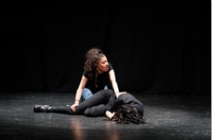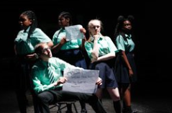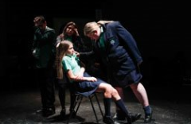 | Sourced | Bishop Challoner School | Images used on a variety of different platforms
Dance images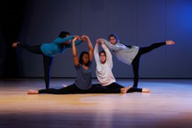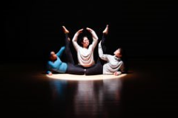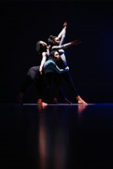 | Sourced | Bishop Challoner School | Images used on a variety of different platforms
Music images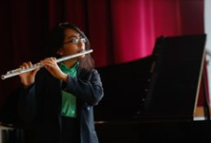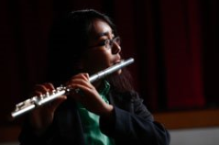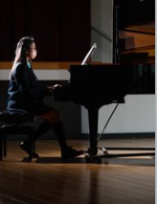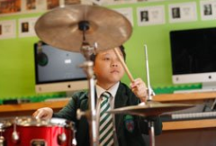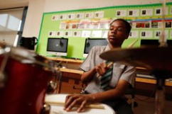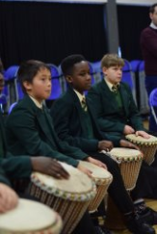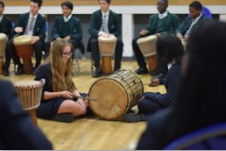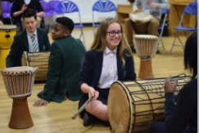 | Sourced | Bishop Challoner School | Images used on a variety of different platforms
Art images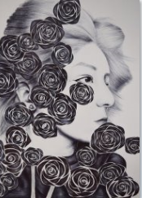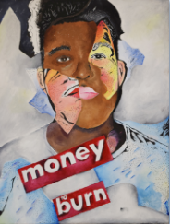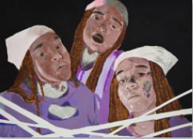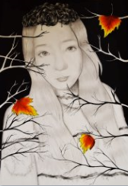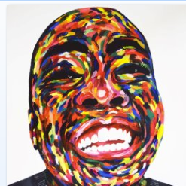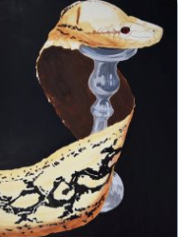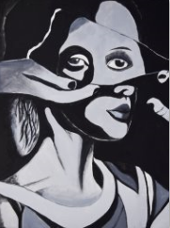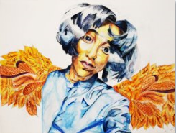 | Sourced | Bishop Challoner School | Images used on a variety of different platforms
Media images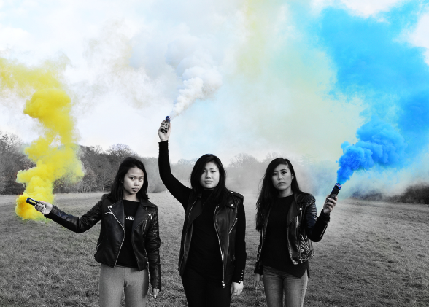 | Sourced | Bishop Challoner School | Images used on a variety of different platforms
DRAMA TRAILER: Boys’ devised piece | Sourced | Drama Department | Converted to Final Cut compatible file
DRAMA TRAILER: ‘Hairspray’ footage | Sourced | Drama Department
DRAMA TRAILER: ‘Stations Of The Cross’ footage | Sourced | Drama Department
ALL TRAILERS & PODCASTS: ‘Express Yourself’ song by Labrinth | Sourced | YouTube | Used small section.  Converted it to audio using MP3 Converter
MUSIC TRAILER: ‘Broken Heart’ song by Year 8/9 Boys | Sourced | Music Department
ART TRAILER: video footage | Sourced | Art Department
DANCE TRAILER:  ‘Dance Shadows’ | Sourced | Dance Department
DANCE TRAILER:  ‘Dance Upside Down’ | Sourced | Dance Department | Had to rotate
DANCE TRAILER:  ‘Dance KS3’ | Sourced | Dance Department
Snapchat Logo | Sourced | www.snapchat.com
Instagram Logo | Sourced | www.instagram.com
Twitter Logo | Sourced | www.twitter.com
Facebook Logo | Sourced | www.facebook.com

