


- PrecisionTRAX easy-to-use software for UAV deployment and management
- FlyNow in-field smart device app
- Waived onboarding fee ($150 value)
- Free pilot rating based on DJI flight logs
- First 25 members to register receive 3 months free!

- 100 free flight minutes (available for 100 days)
UAVAir operators conducting an Australian
coastal survey using PrecisionTRAX
PrecisionTRAX Limited Time Offer for Drone User Group Network Members

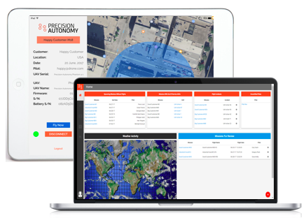
- PrecisionTRAX easy-to-use software for
UAV deployment and management
- Waived onboarding fee ($150 value)
- Free pilot rating based on DJI logs
- First 25 members to register receive 3 months free!
Be one of the first in the US to access our drone deployment and management software. In PrecisionTRAX, operators can log missions and flights, manage assets, pilots, and much more. For a limited time, Drone User Group Network members can participate.

The offer includes:
If you fly with DJI and provide your flight logs, we can calculate your confidential pilot rating using our Underwriter approved rating algorithm. We are working on a new insurance offer that will be made available to DUG members!

FAQ
About Precision Autonomy
We are a global company committed to making unmanned vehicles a safe reality.
Check us out at precision-autonomy or contact us at dugn@precision-autonomy.com
Precision Autonomy LLC provides PrecisionTRAX. Its features were designed from real-time use and feedback from UAV Operators and Insurers. It will be revised regularly to reflect enhancements or updates.

