Image Mapping:
Engaging international volunteers and
making impact in rural communities
6th-12th March 2020 in Kötschach-Mauthen, Austria

Background of the seminar
When we organize youth projects and volunteering camps in the countryside, it can sometimes feel like a parallel universe: Youth from all around Europe engages in an intense intercultural exchange, while there is not necessarily a lot of interaction with the local community. We want to change that and strengthen the local impact of international volunteering projects. We will organize first this seminar for youth workers in March in Ukraine and then a pilot youth exchange in July in Ukraine.

In this seminar, camp coordinators and youth workers from around Europe will gather to learn and exchange, among other topics:
- Non-formal education methods around making international volunteers interact with rural communities
- Best practices of engaging international volunteers in rural communities, among them the „Image Mapping“ project from Ukraine
- How to create intercultural events in villages
- How to reach rural youth to participate in international volunteering projects
- Group dynamics of international youth projects in the countryside

As an outcome, we will create a manual on how to create interaction between international volunteers and rural communities. The manual will include method descriptions and guidelines for youth and volunteering organisations to be used.

Participant’s profile
The participants will be staff, activists and volunteers from volunteering organisations, youth organiations, municipalities and other institutions. All participants will be expected and stimulated to contribute to the activities and discussions. They are very welcome and invited to come up with their own ideas and present some methods or workshops they are experienced in and they want to share. Please contact us in advance to tell us about it and we will see how it can fit in the seminar agenda. :)

All participants selected for this project must meet the following criteria
- be 18 years old or older
- work with volunteer management or organising volunteering projects in their sending organization
- be able to work in English
- be interested in the seminar topics (rural development, international volunteering) and have a strong motivation to act as a multiplier
- commit to implement the learned knowledge and skills in practice back home
- commit to actively participate from the beginning to the end of the training
We explicitly encourage participants of all genders, sexual orientations, abilities and ethnic backgrounds to apply.

Please note that on some days, the seminar also foresees evening sessions. The seminar will take place in simple living conditions, rooms are shared between 2 to 4 people. Travel costs (up to a maximum amount, depending on country), accommodation, food and program are covered through a grant by Erasmus+.

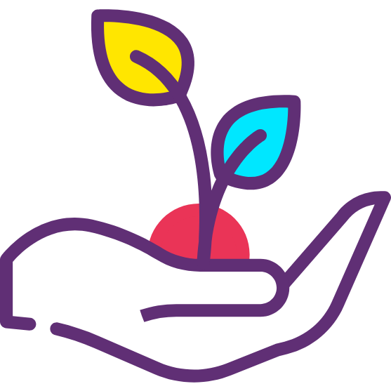
Sustainable food: The food we provide will be vegetarian with vegan options. This is not just a practical decision, but also an ideological one: SCI believes in the values of sustainability and climate justice – and if we want to contribute to a more peaceful planet, we need to give up on animal agriculture and its destructive effects on our planet.


Sustainable travels?: This is also why we ask you to come to this seminar through more sustainable means of transport rather than flying (e.g. by train or bus), if somehow possible. We will give you more guidance on how you can reach the venue, once you are accepted to the seminar.

How to apply?
Applications should be sent to your sending organization, which will each select their own two participants and then forward the applications to SCI Austria. All those accepted will later receive a detailed infosheet (incl. info on how to get to the venue, how to book your travels, more info about the agenda of the project). Deadline for applying is 03.01.2020.

Contact
If you have any questions regarding the project and your application, don't hesitate to contact us at thomas.schallhart@gmx.at.

We are looking forward to your application :-)

The coordinating team
Iaro, Thomas and the SCI Austria team
Application form
Image Mapping, 6-12 March 2020
Surname
First name
Is your official name in your passport different? If yes, please let us know:
Gender
Birth date
Nationality
Personal Address
(Street, city, country)
Phone Number
E-mail
Emergency person
Contact Emergency person
(phone / email)
Special food needs?
(Allergies, intolerances, diet, etc.)
Other needs you would like to communicate
(e.g. Want to sleep in room with people of the same gender, disability, health conditions, etc.)
(if visa required)
Passport Number, Date of Issue and Date of Expiry
English skills | Very good | Good | Poor
Speaking
Writing
Understanding
Name of your sending organisation

For the following questions, please write briefly your most important arguments. This will help us to design of the training according to your and the whole group‘s needs.

Experiences
How long have you been involved in your organisation and what have been your roles and tasks?
What experiences with involving volunteers from rural areas or/and organising international volunteering projects have you made?
Motivation and expectations
What are the main reasons you wish to participate and what are your expectations for the seminar?
How do you want to use the acquired tools and knowledge in the future?
Do you have an idea for a method or session that you could share at the seminar?
Please give details, if possible: time needed, number of participants, kind of activity, topic
Further information
You can state here any other information you would like to share:

Declaration and commitment
I am fully aware that my participation in this activity is an investment of the organisers (in terms of logistics, finances, time and personal involvement of all people engaged) in my personal learning experience.

1. I declare that the information provided in my application is true and I commit myself to participate actively in the whole duration of the project.
2. I promise to share the experiences gained in the course with other people from my sending organisation and/ or other people in my professional/ private / volunteer environment;
3. I promise to implement learned experience at the local level;
4. I commit to attending the seminar in full, with no late arrival and early departure or leaving sessions;
I read and understood text of the declaration.

