How Do You Make An Invisible Folder On Window Or Mac?
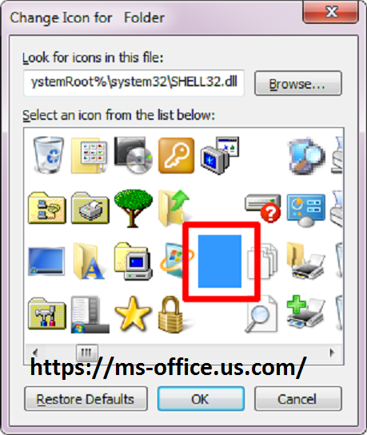
While creating hidden folders is straightforward , an equivalent isn't the case with invisible folders. If you would like to cover your sensitive data, then you'll put it in an invisible folder. Follow the method given below and make invisible folders on your Windows PC or Mac. See www.office.com/setup 365 personal

Check this link>>> Benefits of Microsoft Access and How to Make Database Super-fast?
Steps to Hide Files on Your Windows Computer

- You have to right-click on the screen. You have to click on the new option given on the pop-up menu and start making a new folder.
- Select which type of folder you wish to create. You will get two options on the pop-up menu which is “Folder” and “Text Document,” and you have to choose only one option.
- Enter a title of the created folder on the edit box.
- Press on the Enter the button given on the computer keyboard.
- You need to right-click on the created folder.
- Press on the Properties option.
- Go through the “Hidden” checkbox.
- Press on the OK button. Now, the folder you have created becomes invisible. In case you make another folder on the same location by entering the same title, then the system automatically adds a number after the title of the folder.
- The folder you have created will not be visible until the computer shows all the hidden files and folder window.

Steps to Find Files on Your Windows Computer

- First, you have to enter “hidden files” into the search box.
- Tap on the “Show hidden files and folders” selection. You will get this option in the top column of the search window.

- Click twice on the “Hidden files and folders” option. In case it's already showing two options there under, then don't follow this step.
- Press on the “Show hidden files, folder and drivers button located in the advanced settings window.
- Press on the OK button.
- Click on the fractious symbol so that the “Hidden files” window gets close.
- Go back to the desktop. You will get all the folders on the desktop which you already have hidden.
- In case you wish to hide the folder again, then you have to press on the “Hidden files and folder” option and tap on the “Don’t show hidden files, folders, or drives” option.

Steps to Hide Files on Your Mac

- You have to right-click on display. You have to start out using the “Terminal” application just in case you would like to cover the folder from the house screen.
- Press on the New Folder option.
- Enter any title for the created folder.
- Press on the Return button.
- Tap on the magnifying glass symbol.
- You have to enter “Terminal” in the search box.
- Pull the created folder into Terminal application.
- Press on the Enter button.

You can visit my website http://office.com/setup activate.

#www.webroot.com/safe #www.avg.com/retail

