The Latest Red Flag For U.S. Shale
By Nick Cunningham - Aug 21, 2017, 6:00 PM CDT
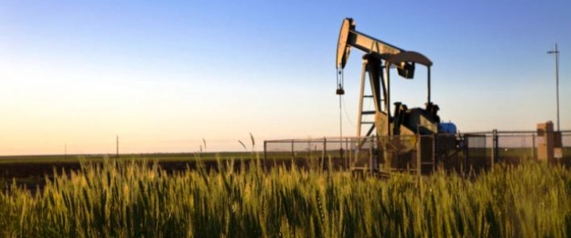
The U.S. shale industry has had a rough few weeks, with a growing number of reports suggesting that the industry is facing much more financial trouble than many analysts had expected. Now, a new report adds further evidence to the notion that shale is losing its luster in a $50 per barrel market, with producers forgoing shale in favor of older wells.
U.S. shale was thought to be the most competitive source of oil out there, and indeed the industry appears to be ramping up production at today’s prices. Shale had adapted to a $50 per barrel market, producers had streamlined operations to make them almost resemble an assembly line, and in a volatile and unpredictable market, the short-cycle nature of shale drilling made it one of the least risky options for drillers.
But in just a few weeks’ time, investors are starting to ask major questions about the viability of shale drilling at such a large scale.

A couple of notable things have occurred in the past month or so. Pioneer Natural Resources, a top Permian producer, raised concerns when it told investors that its Permian shale wells were coming up with a higher natural gas-to-oil ratio than expected, a potentially worrying sign. The company also reported that it had trouble with some of its wells, forcing it to delay some completions.
Separately, Goldman Sachs reported that top investors are souring on U.S. shale E&Ps, with poor performances leading investors to search for ways to “reallocate capital” elsewhere in the energy space. That is big red flag for the shale industry, which is still struggling to consistently post profits despite the highly-touted cost reductions over the past few years.
Related: Are Investors Bailing On U.S. Shale?
But the newest sign of trouble comes from the Wall Street Journal, which just reported that more oil producers are shunning shale drilling and using their scarce dollars to reinvest in older conventional wells. “As crude prices languish under $50 a barrel, and with increasing costs for land, labor and infrastructure, some shale fracking operations are starting to look expensive,” the WSJ reported.
The WSJ says that although Wall Street has showered the shale industry with billions of dollars in capital, and although that has led to a surge in oil production, shale producers by and large are still not profitable. At today’s prices, the WSJ says, “most producers are losing money on every barrel they pump.”
As a result, some oil companies are returning to conventional wells – long thought to be much less attractive today than new shale drilling – and trying to tap them again to squeeze out more oil. The cost to drill a conventional well is a fraction of that for a shale well – $1 million per well versus upwards of $8 million. But those types of wells, in many cases, were taken offline decades ago during periods of low oil prices and declining production.
However, technology has advanced quite a bit since some of these older wells were last online. A couple of companies profiled by the WSJ are tapping old wells outside of Los Angeles, Fresno, and in Oklahoma, Louisiana and parts of Texas. These wells produced a handful of barrels per day, but tapping them again with new drilling techniques allow drillers to squeeze out something like 100 barrels per day, a profitable play considering the low investment required.
One company told the WSJ that the old well essentially breaks even at $15 per barrel.
Part of the problem for U.S. shale is that it is showing some bubble-like symptoms. Land prices have soared in the Permian as so many top shale producers shifted their resources to West Texas in the past few years. Even the oil majors started to scale down their billion-dollar investments in places like Canada’s oil sands, or major LNG export terminals, or offshore drilling, instead reallocating capital to the Permian.
While land prices are inflated, the supply of oilfield services has also tightened significantly. A shortage of fracking crews and other equipment and services has also contributed to higher production costs as well as delays.
Related: Canada’s Oil Industry Doomed If Prices Fall Lower
The result is rising costs for shale at a time when production problems are also starting to crop up. All the while a long list of companies are still not profitable, despite succeeding in boosting production.
The contrarian strategy, then, seems to be returning to old conventional wells, even small ones, and trying to eke out a few more barrels.
With all of that said, retapping old wells probably won’t lead to a rush of new supply since we are stilling talking about relatively small numbers. But it’s a striking development that some ancient wells are getting a second look by companies falling out of love with U.S. shale.
By Nick Cunningham of Oilprice.com

