Rapid Fire Keto | Rapid Fire Keto Reviews | What Is Rapid Fire Keto?

There are a many individuals who are experiencing corpulence or overweight, and there is an extraordinary need to guarantee that you are rapidly shedding the abundance calories from the body by having a solid weight reduction schedule. Utilization of a dietary item for yourself appears to be simple as it will help you in disposing of the abundance calories from the body. For this reason, we are here to present you an astonishing weight reduction recipe known as Rapid Fire Keto.

Around Rapid Fire Keto Weight misfortune item
Rapid Fire Keto is known as truly outstanding and compelling weight reduction supplements that assistance in the ketosis cycle. All things considered, Ketosis is an interaction wherein our liver delivers a chemical called Ketones. In the creation, the body devours put away fat and convert that fat into Ketosis. Thusly, you lose fat. It is fundamental to consider that the energy from these Ketones is a lot higher instead of the energy from glucose.
Keep in thought that NatraSlim Keto weight reduction item is fundamentally implied for individuals who are searching for a fat misfortune diet. Alongside this, you can likewise attempt this item assuming you need to get thinner in only a couple weeks.
It is interesting to realize that the pills of Rapid Fire Keto will ensure that you are not letting any undesirable calories. Besides, the item likewise empowers you to get yourself far from stoutness as it additionally further develops your wellbeing system.
Alongside this, these pills will ensure that at whatever point you begin devouring it, then, at that point the body will help you in lessening the weight.
Elements of Rapid Fire Keto
First and foremost, remember that Rapid Fire Keto weight reduction supplement is made out of all-regular parts that help you in becoming fit. Also, the fixings utilized in the pills of this weight decrease recipe are removed from useful plants and spices. They guarantee that your body is delivering a lot of proteins and nutrients that are fundamental for keeping you fit.
In addition, these pills will likewise help you in ensuring that your body goes through the cycle of Ketosis. It must be conceivable because of the presence of BHB or beta-hydroxybutyrate that will deliver ketones in your body. Ketones are fundamental for consuming calories from the body. BHB additionally guarantee that once the fat from the body is scorched, then, at that point it will be utilized for delivering more energy to shed more fat.
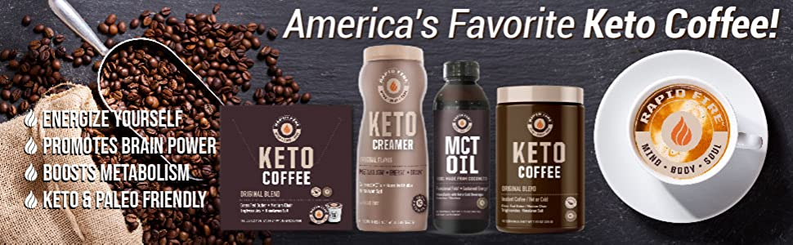
Fundamental focuses to know
It is essential to remember that weight reduction equation. This weight reduction supplement doesn't deal with your body in case you are not over the age of 18.
Alongside this, individuals who are dependent on smoking or drinking then they won't get any certain effects from Rapid Fire Keto.
In case you will conceive an offspring, NatraSlim Keto will likewise not work on the body.
Keep in thought that assuming you are eating different prescriptions alongside this weight reduction supplement, there is incredible need to diminish the overabundance fat from your body rapidly.
Advantages of Rapid Fire Keto Tablet
It helps in the anticipation of fat development
It works on the digestion of your body

It helps you in controlling your appetite
It likewise upgrades the general wellbeing
It supports up the whole energy level of the body
It works on the psychological core interest
It further develops fixation power.
Detriments of Rapid Fire Keto Diet
Just the producer is the provider of NatraSlim Keto item
The thing isn't intended for minors
Pregnant and lactating women ought to stay away from NatraSlim Keto weight reduction supplement
A heavy drinker individual should quit drinking while at the same time utilizing these pills
Heart patients are likewise not permitted to take NatraSlim Keto supplement.
The day by day dose of Rapid Fire Keto Pills
While eating the pills of Rapid Fire Keto, there is an extraordinary need to guarantee that you are taking it multiple times in a day. Alongside this should ensure that you are burning-through the thing three hours prior to eating the suppers of your morning meal and supper.
Notwithstanding, keep in thought that you are burning-through NatraSlim Keto weight reduction recipe once toward the beginning of the day and the evening.
While eating NatraSlim Keto weight reduction thing consistently ensure that you are devouring it alongside a glass of warm water that help you in dissolving the pills in the body.
Additionally, ensure that you are keeping yourself hydrated to keep the body sound.
It is crucila to remember that you are eating a ketogenic diet in which you are eating fats and proteins. NatraSlim Keto diet will help you in rapidly decreasing the abundance calories from the body.
The purchaser of Rapid Fire Keto pills should practice routinely. The explanation is that it will expand your endurance and perseverance. In case you can't get some an ideal opportunity for your rec center meeting, go for a stroll in the recreation center or play some outside games and considerably more.
Results of Rapid Fire Keto Supplement
Keep in thought that NatraSlim Keto recipe is an advanced fat misfortune equation up of 100% unadulterated normal fixings. No incidental effects have been accounted for by utilizing this item, however you should accept it according to the expressed rules. Besides, you need to take NatraSlim Keto supplement consistently.
Where to Buy Rapid Fire Keto?
In case you make certain around Rapid Fire Keto pills, you can undoubtedly arrive at the producer's site and spot request straightaway. There is no difficulty to get it from the authority webpage on the grounds that the connection to the authority site is given underneath this passage. Simply click on the picture given underneath, another tab springs up to the program.
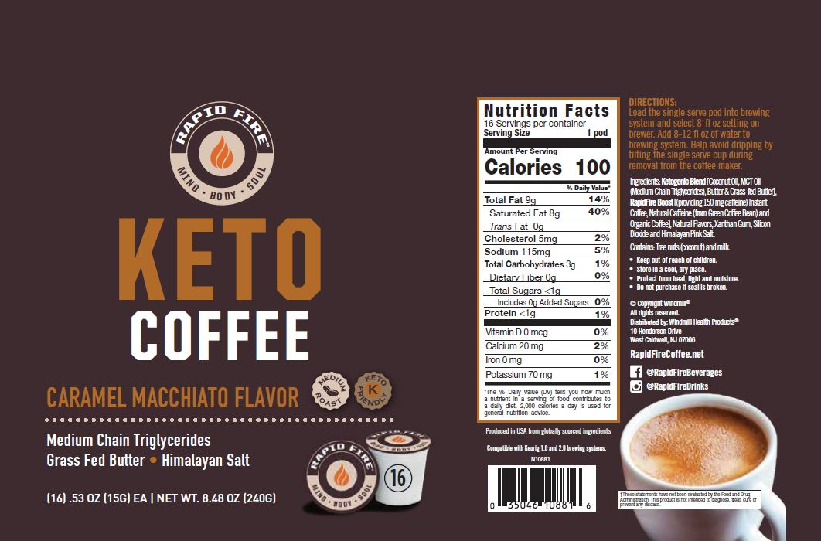
Last decision
The pills of Rapid Fire Ketohelp you in ensuring that you are effectively consuming the overabundance calories. Additionally, the item likewise empowers you to become sound. The recipe is extraordinarily planned to guarantee that you are not amassing any abundance calories in the body. In this way, begin burning-through the pills of NatraSlim Keto and bid farewell to weight. It's 100% normal fixings to shed undesirable calories from your body.

