Instazoom - The Easiest Way to Download and Enlarge Instagram Photos
Instagram is a great way to share photos with friends, family, or the world. But what if you want to download your own photos, or share them with others in a larger format? Instazoom makes it easy to do just that! Let’s take a closer look at this handy tool.
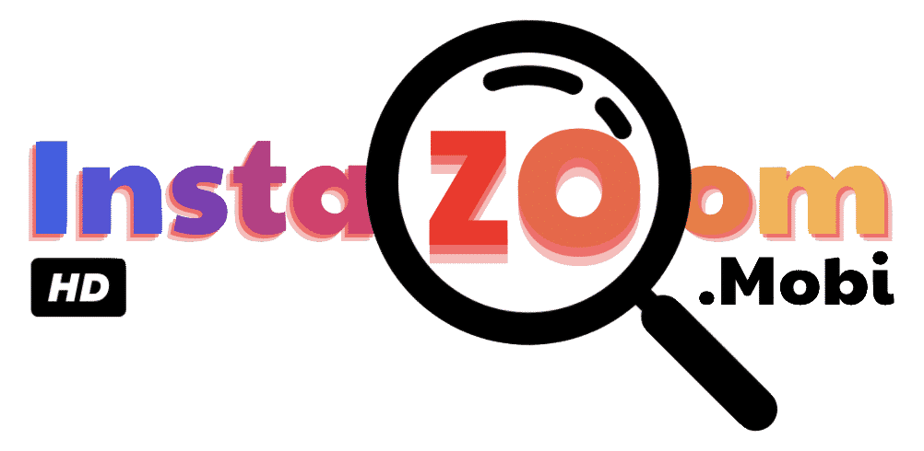

Why use Instazoom?
Instazoom is the easiest way to download and enlarge your favorite Instagram photos. Just enter the URL of the photo you want to save and Instazoom will automatically generate a high-resolution image for you. Not only does Instazoom make it easy for you to save your own photos, but it also allows you to share larger versions of other people’s images with friends and family. You can even use Instazoom to create high-quality prints for framing or other art projects.

How Does It Work?
Using Instazoom is incredibly simple. All you have to do is copy and paste the URL of an Instagram photo into the search bar on the website. Then, click “Go” and wait while the photo is processed by Instazoom’s servers. In just a few seconds, you will have access to a full-size version of the image that can easily be downloaded or shared with others via email or social media platforms like Twitter or Facebook. It really couldn’t be easier!

What Are Some Other Benefits? One of the best features of Instazoom is its ability to crop images without distorting them in any way. This means that no matter how large (or small) an image is, it will still retain its original proportions when cropped using Instazoom - something that would otherwise be impossible on smaller smartphone screens or tablets. Plus, because all processing takes place offsite via cloud computing technology, there's no need for additional software downloads — saving time, energy, and money in one fell swoop!

Conclusion
Whether you are looking to download your own images from Instagram or share larger versions of other people’s pictures with friends and family, Instazoom makes it easy! With its simple interface and fast processing times, downloading full-sized photos has never been easier. So put down that smartphone screen – downloading large images just got a whole lot simpler thanks to Instazoom!

