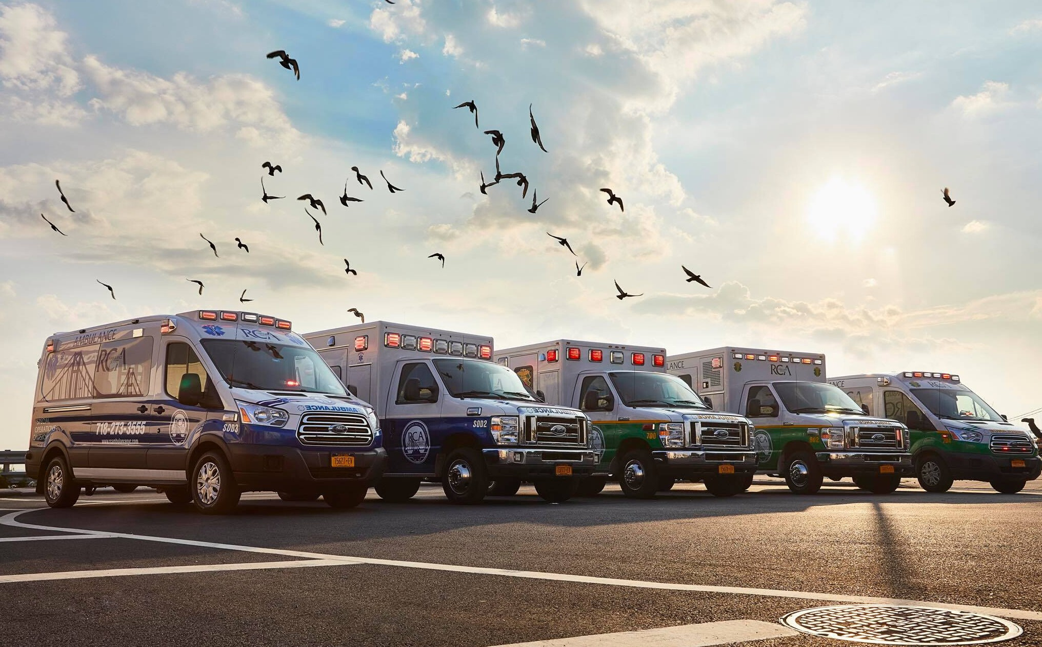
PREPARATIONS MAY HELP YOU BAG A PARAMEDIC JOB IN BROOKLYN

One needs to have a decent idea if not the training for being a paramedic prior to appear for a paramedic job in Brooklyn. Learning all the emergency measures should be considered ideal for any paramedic providing the life support to a victim or a person in a grave condition. The paramedics can help people breathe until they reach the hospital and so, complete efficiency for the job should certainly be preferred prior to awarding the job of a paramedic to any candidate. For More Information Please Visit Our Website:
rcambulancenyc.candidatecare.jobs

