Bong88 – Nhà cái uy tín đến từ châu Âu

Mô tả ngắn Bong88:
Bong88 - Nhà cái uy tín đến từ châu Âu
Website: https://bong88bet.day
SĐT: 0375503541
Mail: bong88bet.day@gmail.com
Địa chỉ: Nguyễn Đức Thuận, Phường 13, Tân Bình, Thành phố Hồ Chí Minh, Việt Nam
#bong88 #bong88bet #nhacaibong88 #bong88nhacai

Tổng quan về nhà cái Bong88
Website https://bong88bet.day là trang web chính thức, mới nhất của nhà cái Bong88. Đây là sân chơi bổ ích với nhiều dòng game cá cược kinh điển như cá cược bóng đá, cá cược thể thao, casino…
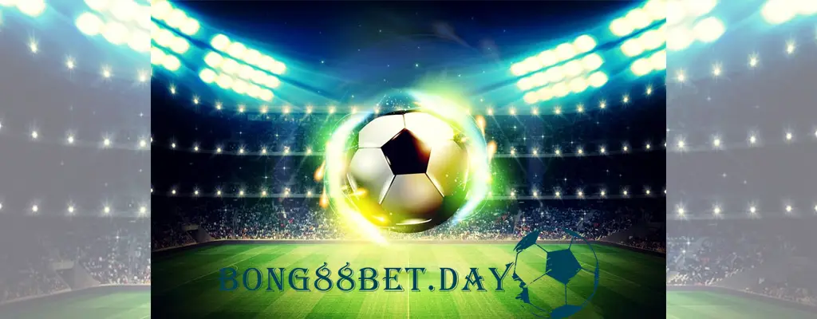
Bên cạnh đó chúng tôi còn có đội ngũ chuyên gia am hiểu sâu về bóng đá và công nghệ thông tin, bong88 tự tin sẽ mang lại trải nghiệm tuyệt với nhất cho người dùng và trờ thành một trong số những website cá cược trực tuyến hàng đầu Việt Nam.

Logo bong88:
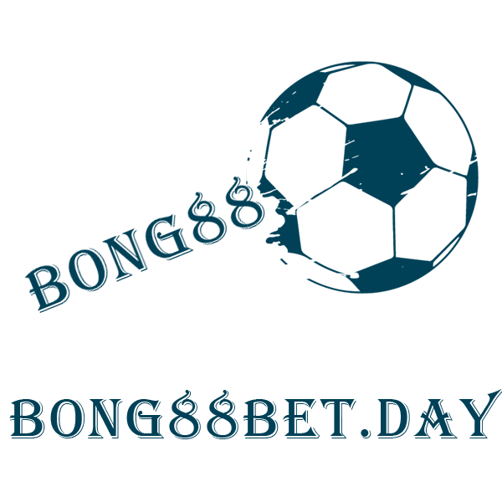


Tổng hợp link google stacking:
Bong88 - Google Drive: https://drive.google.com/drive/folders/1oBF4CGGOLQeb2oYifyqP-w5a4H6Grpdb?usp=sharing
Bong88 - Google Sheet:
https://docs.google.com/spreadsheets/d/1qK3zNjKC94JyAIQXc0hJdd1d9muQw3Y8vJuNN-olPbk/edit#gid=0
Bong88 - Google Doc:
https://docs.google.com/document/d/1fJaljcrtgNdP5sn-MioQPFo9rDxEhcsSbU2ijg6M4M0/edit
Bong88 - Google Slide:
https://docs.google.com/presentation/d/1nqK1wXa1LwmX3syFk0LWm-2x8pqOzlL7qwxqiYxKUwI/edit#slide=id.p
Bong88 - Google Form:
https://docs.google.com/forms/d/e/1FAIpQLSfxey-ityWsogg70LNYtPv7ef-HpgTYZI3-o1Ini1KA8cGRdA/viewform?usp=sf_link
Bong88 - Google Draw:
https://docs.google.com/drawings/d/1oS_jM_FamCYkk-jwU2Vv8pBUAA10wy3dmR1AFgYPI-o/edit?usp=sharing
Bong88 - Google Map:
https://www.google.com/maps/d/viewer?mid=15Stm7bZXwIbZRNYbVxVVz53ypWp70Ao&ll=10.80857734824042%2C106.64313592544814&z=17
Bong88 - Google Site:
https://sites.google.com/view/bong881/trang-chu
Bong88 - Blog:
https://bong881.blogspot.com/
Bong88 - Jamboard:
https://jamboard.google.com/d/1ue2himX9pk72b0OPj7WOmbDP88_7l7O_PYdUh_pIEfs/edit?usp=sharing
Bong88 - Youtube:
https://www.youtube.com/channel/UCTl6hVkBLr5kloXMqVGUadg
Bong88 - Photo:
https://photos.app.goo.gl/eMfPpEmaNP1jZ7eB9
Bong88 - Script:
https://script.google.com/d/1QPh8d6U4N0jHkc8S8pzuttL6hDPg6VDK5sDQKhBf_29-9O2FNsNynvEA/edit?usp=sharing

Tổng hợp link social:
Bong88 - Youtube: https://www.youtube.com/channel/UCTl6hVkBLr5kloXMqVGUadg
Bong88 - Facebook:
https://www.facebook.com/people/Nh%C3%A0-c%C3%A1i-Bong88/100089922320024/
Bong88 - Instagram:
https://www.instagram.com/bong88bet.day/
Bong88 - Twitter:
https://twitter.com/bong88casino
Bong88 - Linkedin:
https://www.linkedin.com/in/nh%C3%A0-c%C3%A1i-bong-89b384265/
Bong88 - Tumblr:
https://www.tumblr.com/bong881
Bong88 - Tiktok:
https://tiktok.com/@nhacaibong88
Bong88 - Scoop.it:
https://www.scoop.it/u/bong88-nha-cai
Bong88 - Flickr:
https://www.flickr.com/people/197717596@N08/
Bong88 - Pinterest:
https://www.pinterest.com/bong881
Bong88 - Gapo:
https://www.gapo.vn/bong881
Bong88 - Twitch:
https://www.twitch.tv/bong881/about
Bong88 - Myspace:
https://myspace.com/bong881
Bong88 - About.me:
https://about.me/bong881/
Bong88 - Github:
https://github.com/bong881
Bong88 - Dribbble:
https://dribbble.com/bong881
Bong88 - Vimeo:
https://vimeo.com/user194227645
Bong88 - Behance:
https://www.behance.net/bong88nhacai
Bong88 - Linkhay:
https://linkhay.com/u/bong881
Bong88 - Patreon:
https://www.patreon.com/Bong88/about
Bong88 - Deviantart:
https://www.deviantart.com/bong881/about
Bong88 - Gravatar:
https://vi.gravatar.com/bong882
Bong88 - Reddit:
https://www.reddit.com/user/bong881
Bong88 - Plurk:
https://www.plurk.com/p/p5kh5e
Bong88 - Quora:
https://qr.ae/pr5iNb
Bong88 - Metroflog:
https://www.metroflog.co/bong88

Tổng hợp link blog 2.0:
Bong88 - Blogger:
https://bong881.blogspot.com
Bong88 - Google Site:
https://sites.google.com/view/bong881/trang-chu
Bong88 - Webflow:
https://bong881.webflow.io
Bong88 - Wordpress:
https://bong882.wordpress.com
Bong88 - Bravesites:
https://bong88.bravesites.com/
Bong88 - Hansdnode:
https://bong881.hashnode.dev/
Bong88 - Wixsite:
https://bong88betday.wixsite.com/bong88
Bong88 - Weebly:
https://bong881.weebly.com/
Bong88 - Odoo:
https://bong88.odoo.com/

