English description of Dakar (NC)
This cache is a big challenge! You have to go by car or quad to succeed the route. If you don’t make any mistakes, the route will have a length of 40 km. During the trip you will travel along dirt tracks. The quality of the track depends on the weather. To complete this route you have to be an excellent driver. THIS CACHE IS ON YOUR OWN RISK.
Welcome to Dakar NC

To finish the cache you have to bring with you:
-Navigator (second person), advisable is a third person.
-Flashlight
-Pen and paperwork

Route
White fireneedles will give you the right direction. If you see a white fireneedles, go the next possibility tot he side you found the fireneedle. Fireneedles are placed 0 – 100m before a possibility to go left or right. If you see no fireneedle, go straight ahead. Beware! Straight ahead is only straight ahead when the direction is exactly in front of you. (not 10m. to the right)
Red (orange) fireneedles are on the track to let you stop the car. You have to find a waypoint. Sometimes you can fin dit directly near the first fireneedle. Sometimes you have to find more (maximum 3) red fireneedles in a short walk to find a waypoint. Write down the Letter/Numbers and put the next coordinate in your GPS device. This coordinate will NOT bring you to a place where you have to find something. It will bring you to a spot you have to drive through. After that, drive in the direction you drove and search the next fireneedle to move on, on the track.
Somewhere in the route, you will find a place with many white fireneedles which will lead you into the bush. Ignore them, they are not part of this cache! Especially near crossing you will find many reflecting things. Sometimes our fireneedles will be near such places. So, if you are doubting about the fireneedle… We recommend you to stop and check if it is a fireneedle. Fireneedles are placed on: Trees, Wooden poles, a plastic pole, on a bench. You have to ignore all dead ends!
Hint: You can spot the fireneedles from a distance the best when you use your big lights on the car. DO NOT DISTURB THE LOCALS WITH YOUR LIGHTS PLEASE.
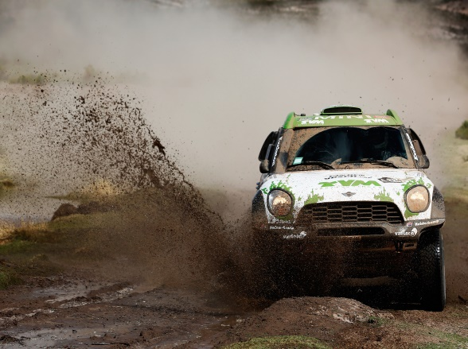
When you will succeed to the final coordinate you have to make a small puzzle with your letters you found. For yo uit will be extra difficult: The answer is only in DUTCH. So… it is not hard to find the anser in english but you have to translate it.
After that, go tot he coordinate you calculated. On that place find a small track (white fireneedles) tot he cache (4 fireneedles.)
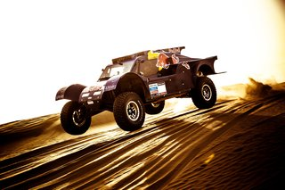
Car: You cannot always bring the cache to an end with each car. You have to drive a car which is not too low near the ground. We (the cacheowners) are driving both a Daihatsu YRV and mostly we can finish the route. So maybe you can compare our car with your own? But Remember… The cache is on OWN RISK.
During this route you have a good change to face wildlife. Please beware.
If you succeed tot he finish, you earn this beautiful banner on your profile page. To check pictures taken during the route, go back tot he geocache page. Thank you!


