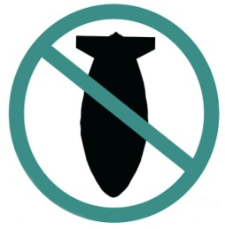

STOP THE WAR COALITION
stopwar.org.uk @STWuk fb.com/stopthewarcoalition
Stop Arming Saudi - End the War on Yemen
Saudi Arabia is fighting a devastating war on Yemen, causing widespread casualties, starvation and suffering. Britain’s arms trade and support for Saudi Arabia continue. We demand that the UK government stops selling arms to Saudi Arabia and breaks links with the Saudi regime.
Name | Postcode | Email | Phone No.
By signing this petition you are agreeing to Stop the War Coalition contacting you by email as part of our campaigning. StWC respects data protection and keeps all your data secure. We do not use your data for any other purpose. Return to: Stop the War Coalition, 86 Durham Road, London, N7 7DT. Tel: 020 7561 4830
By signing this petition you are agreeing to Stop the War Coalition contacting you by email as part of our campaigning. StWC respects data protection and keeps your data secure. We do not sue your data for any other purpose.
Return to: Stop the War Coalition, 86 Durham Road, London N7 7DT. Tel: 020 7561 4830

